SCIENTIFIC CALCULATOR

GROUP ID:03

GROUP MEMBERS:

NAME:MAHMUDUL ISLAM PARTHO

ID:2019-3-60-027

NAME:MD.IFTEKHAR HOSSAIN KHAN

ID:2020-3-60-073

NAME:MOHAMMAD FAHIM HOSSAIN

ID:2019-3-60-026

**DEPARTMENT: COMPUTER SCIENCE AND ENGINEERING**

**EAST WEST UNIVERSITY**

**BANGLADESH**

|  |  |  |  |  |
| --- | --- | --- | --- | --- |
|  |  | **Max.** |  | **Awarded** |
|  | |  |  |  |
| **A. Report** | |  |  |  |
|  |  |  |  |  |
| i. | Introduction / Problem statement |  |  |  |
|  |  |  |  |  |
| iv. | System Design |  |  |  |
|  |  |  |  |  |
|  |  |  |  |  |
| v. | Program output (Screen shots) |  |  |  |
|  |  |  |  |  |
| vi. | Source code |  |  |  |
|  | |  |  |  |
| vii. Disk/CD neatly attached (Y/N) | |  |  |  |
|  | |  |  |  |
|  | |  |  |  |
| **B. Source Code** | |  |  |  |
|  |  |  |  |  |
| i. | Style |  |  |  |
|  |  |  |  |  |
|  | Indentation |  |  |  |
|  |  |  |  |  |
|  | Self-documentation |  |  |  |
|  |  |  |  |  |
| ii. | Modularity (small size functions) |  |  |  |
|  |  |  |  |  |
| iii. | Error reporting capabilities |  |  |  |
|  |  |  |  |  |
| iv. | Code efficiency, strategy, and originality |  |  |  |
|  | |  |  |  |
|  | |  |  |  |
| **C. Program Execution** | |  |  |  |
|  |  |  |  |  |
| i. | Compile without errors |  |  |  |
|  |  |  |  |  |
| ii. | User friendly |  |  |  |
|  |  |  |  |  |
| iii. | Error free during runtime |  |  |  |
|  |  |  |  |  |
| iv. | Program output |  |  |  |
|  | |  |  |  |
|  | |  |  |  |
| **D. Presentation and Demonstration [Psychomotor Domain]** | |  |  |  |
|  | |  |  |  |
| i.  Presentation and communication skills (**Soft skill)** | |  |  |  |
|  | |  |  |  |
|  | |  |  |  |
| **E. Bonus** | |  |  |  |
|  |  |  |  |  |
| i. | Extra significant features |  |  |  |
|  |  |  |  |  |
|  | **TOTAL** |  | **11** |  |
|  |  |  |  |  |

**Project Evaluation Rubrics**

**DECEMBER,2020**

**28.12.2020**

**CSE103 – Structured Programming**

**Project Declaration**

**(Student 1)**

**Student ID 2020-3-60-073**

**Name Md.Iftekhar Hossain Khan**

**Session Fall 20**

**Project No. 01**

**Date submitted 07/01/2021**

**Deadline of the project 07/01/2021**

**My contribution in doing this**

**project (in percentage) in the group 40**

**Description of my contribution in this code , flow chart , report**

**project in the group**

**Number of hours I spent in doing this Approximately 16-18 hours**

**project**

**(Student 2)**

**Student ID 2019-360-027**

**Name Mahmudul Islam Partho**

**Session Fall 20**

**Project No. 01**

**Date submitted 07/01/2021**

**Deadline of the project 07/01/2021**

**My contribution in doing this**

**project (in percentage) in the group 30**

**Description of my contribution in this**

**project in the group code , flow chart , report**

**Number of hours I spent in doing this**

**Project Approximately 12-14 hours**

**(Student 3)**

**Student ID 2019-3-60-026**

**Name Mohammad Fahim Hossain**

**Session Fall 20**

**Project No. 01**

**Date submitted 07/01/2021**

**Deadline of the project 07/01/2021**

**My contribution in doing this 30**

**project (in percentage) in the group**

**Description of my contribution in this**

**project in the group code , flow chart , report**

**Number of hours I spent in doing this**

**Project Approximately 12-14 hours**

**We hereby certify that this project represents the work done by all our group members with our contribution clearly stated above without copying from any other resources. We declare that no part of our work has been copied from or by other groups, and that no collusion has taken place with any other persons or groups.**

**We certify that any disks submitted with this project have been virus checked and have no viruses on them.**

(1) Signature: ……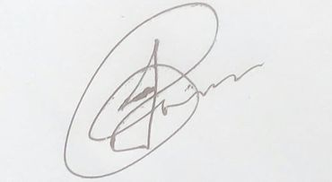…… Date: 06/01/2021

(2) Signature: 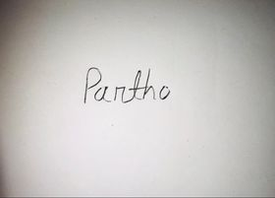 Date: 06/01/2021

(3) Signature:  Date: 06/01/2021

INTRODUCTION

Scientific Calculator:



Scientific calculator which can calculate any mathematical operations such as numeric conversion (decimal, binary, hexadecimal and octal) trigonometric function, factorial, logarithms etc. Our programmed scientific calculator can take input from user. After each calculation, scientific calculator programmed as whether s/he want to continue calculation or not. If yes, it can show functions options. If no, it can show the result and exit option. We use file to store the result of each calculation. End of calculation, user can see their each calculation results.

The Calculator is written in C program and you are welcome to view the code (regarding scientific calculator) below that we are created for this project.

Flow chart

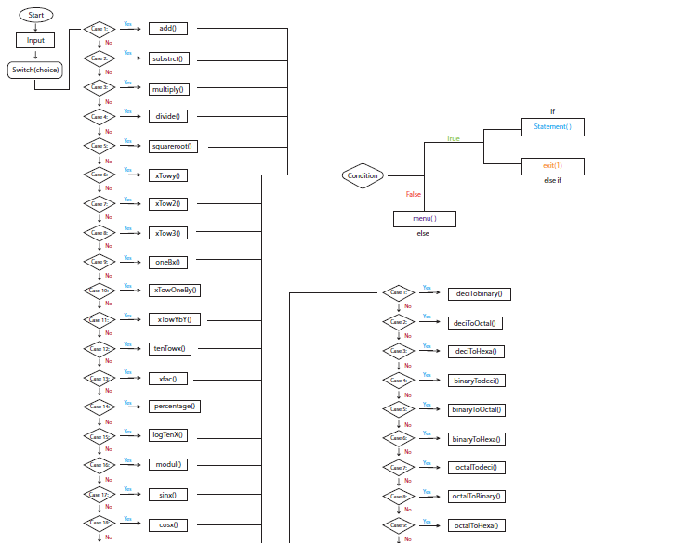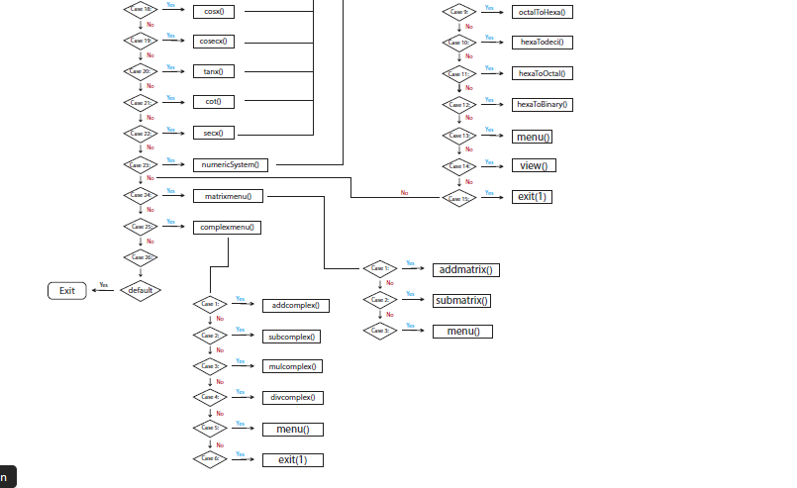

PROGRAMME OUTPUT SCREENSHOT

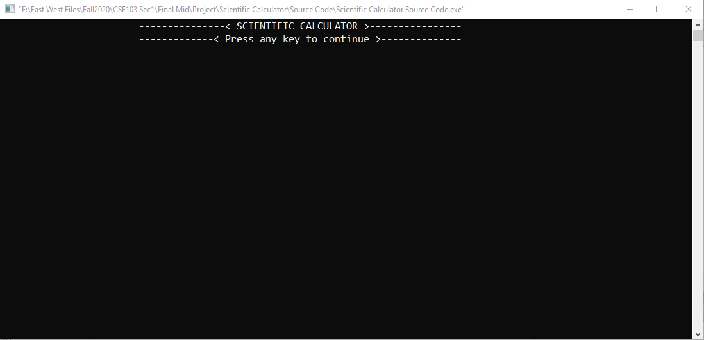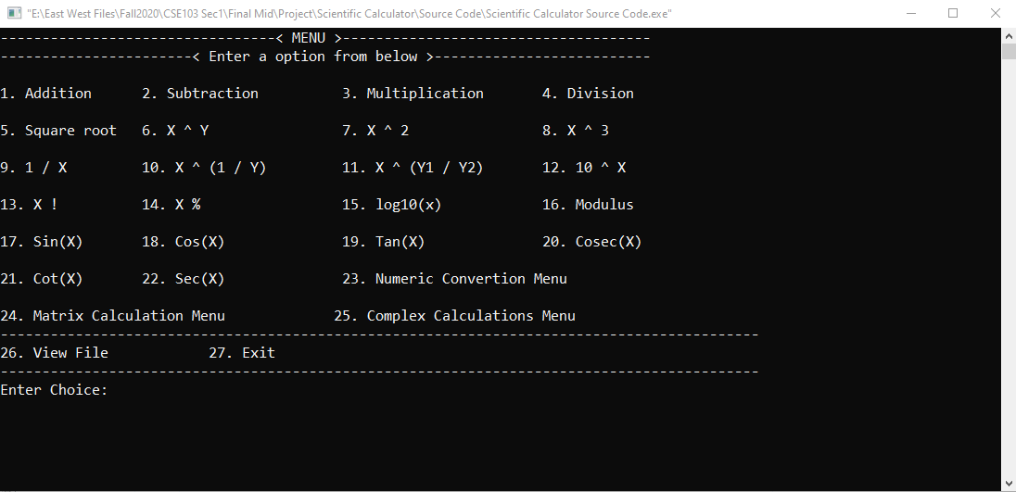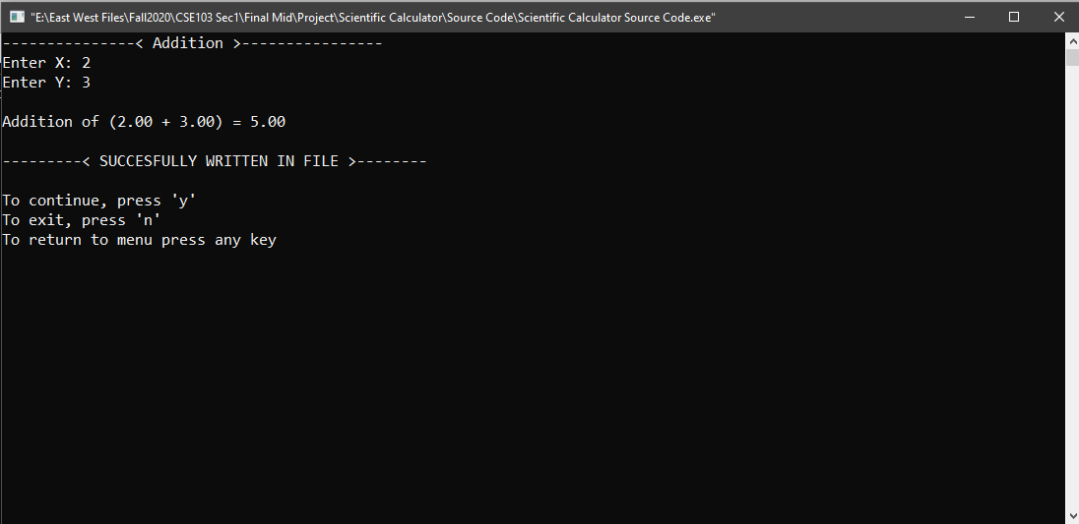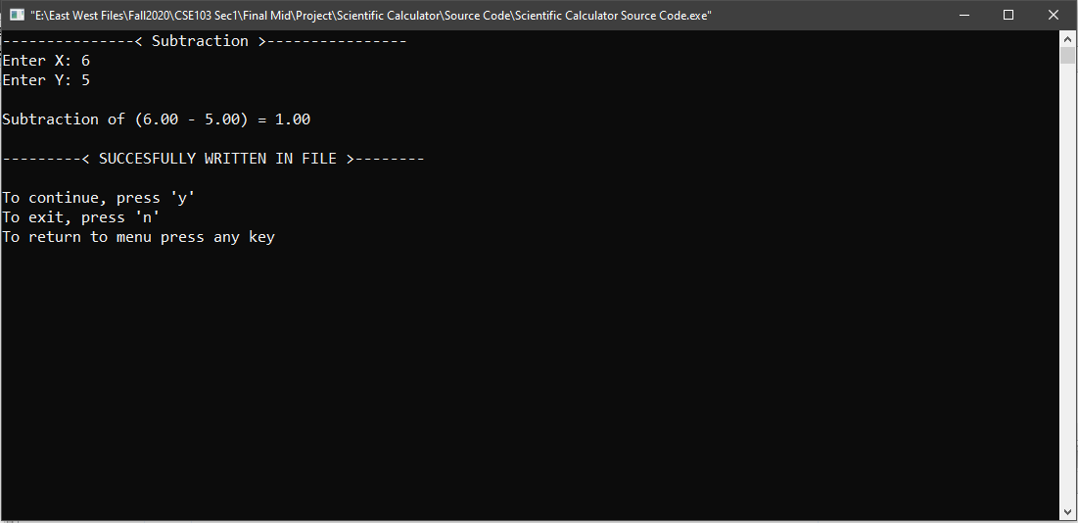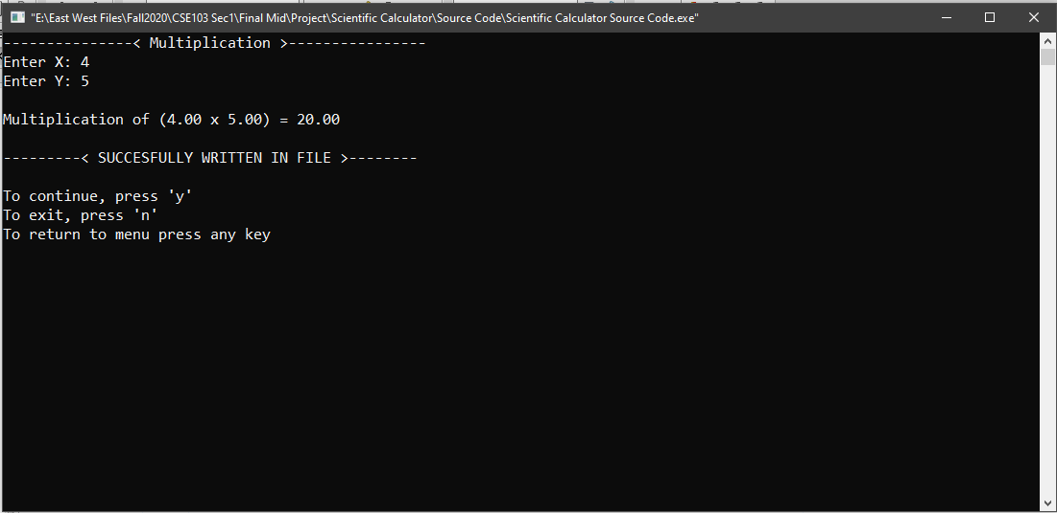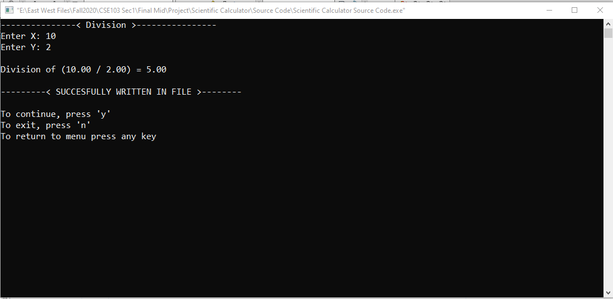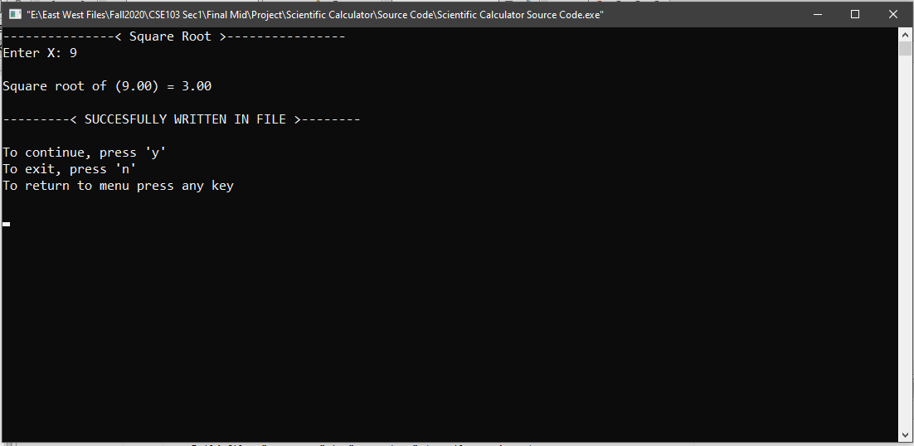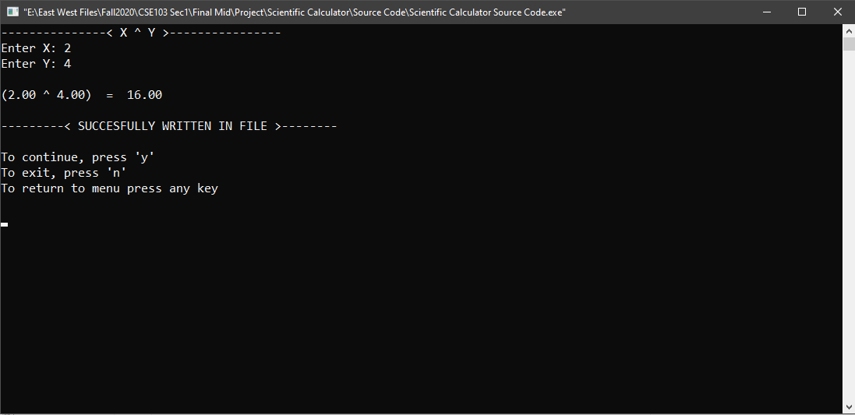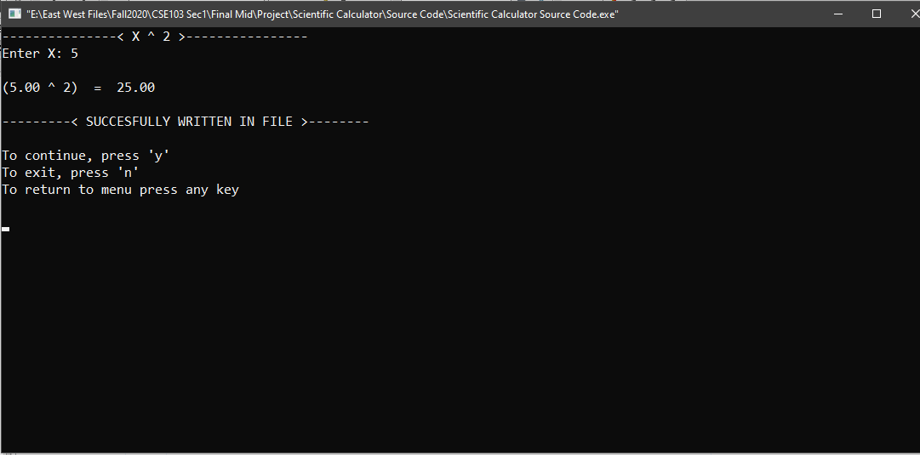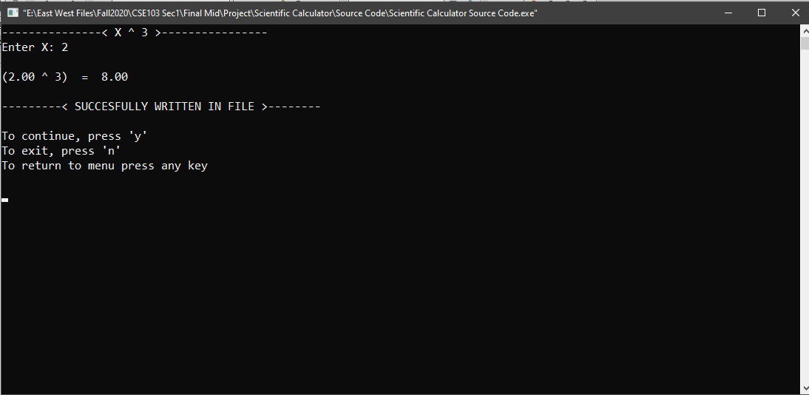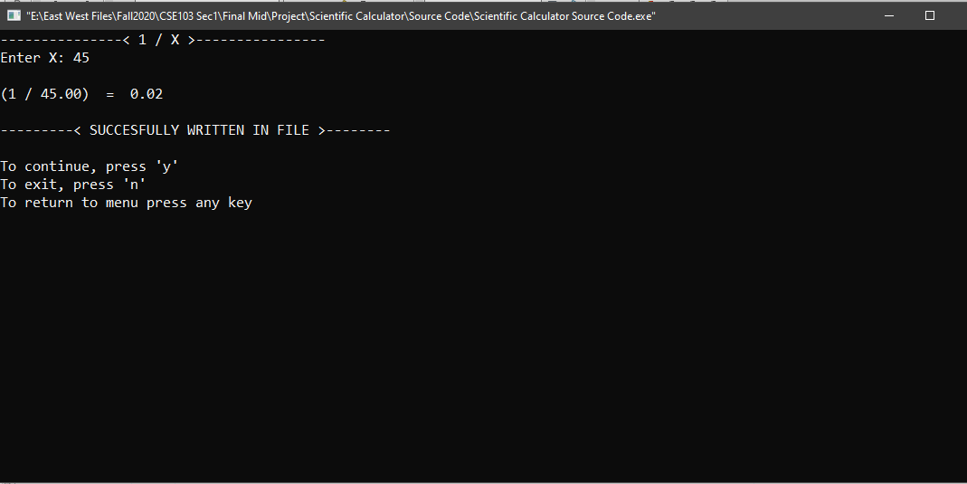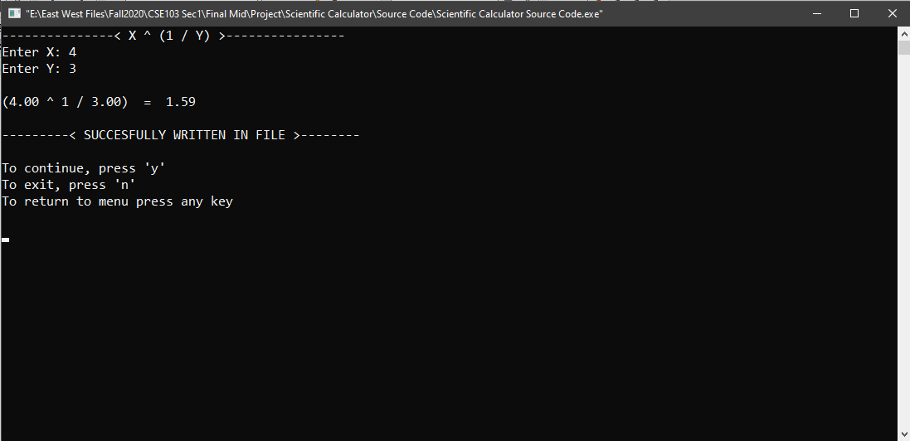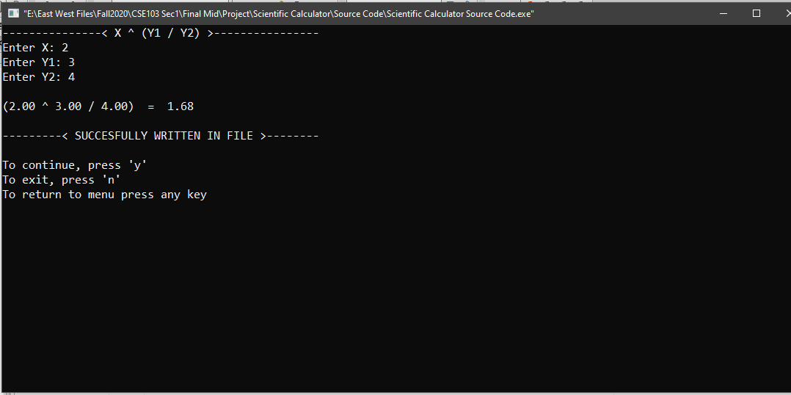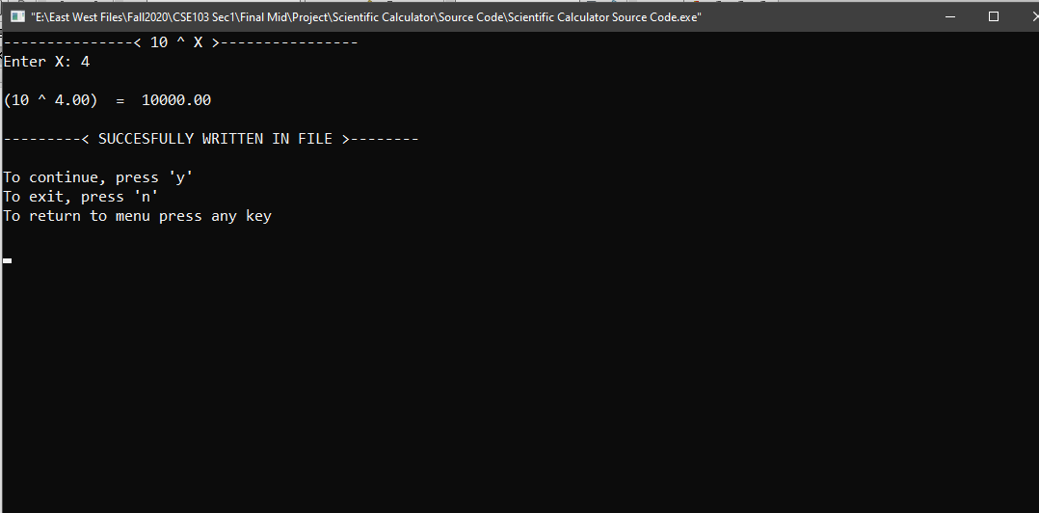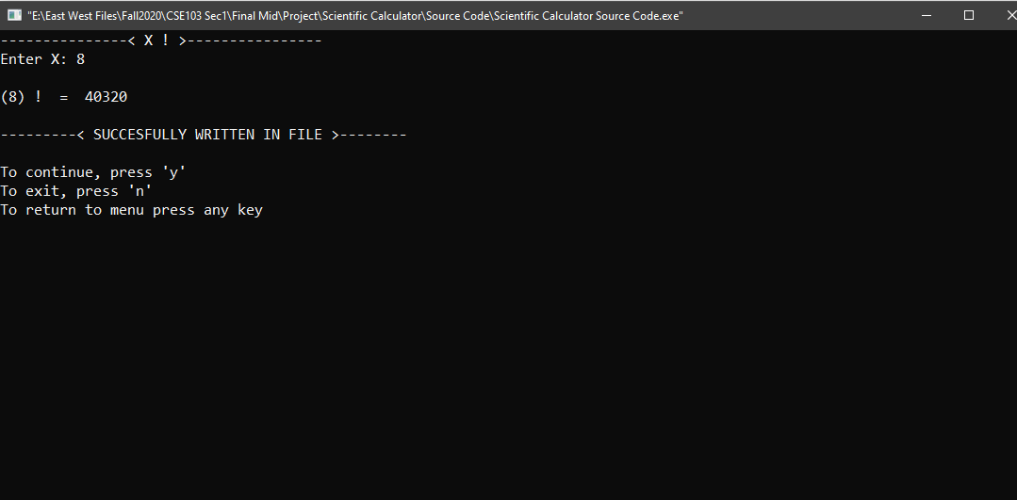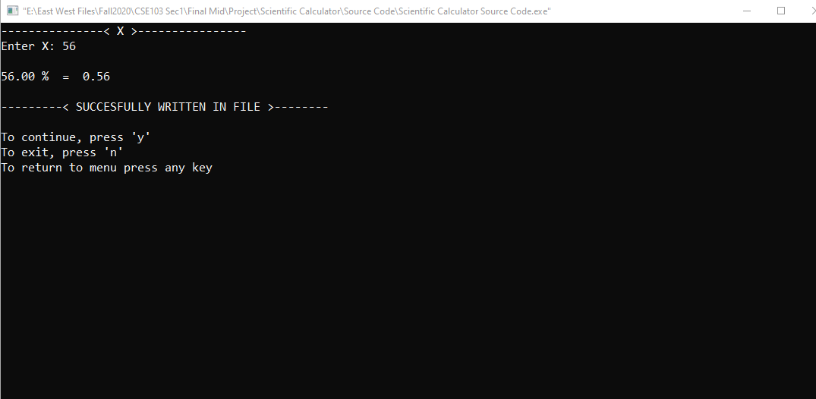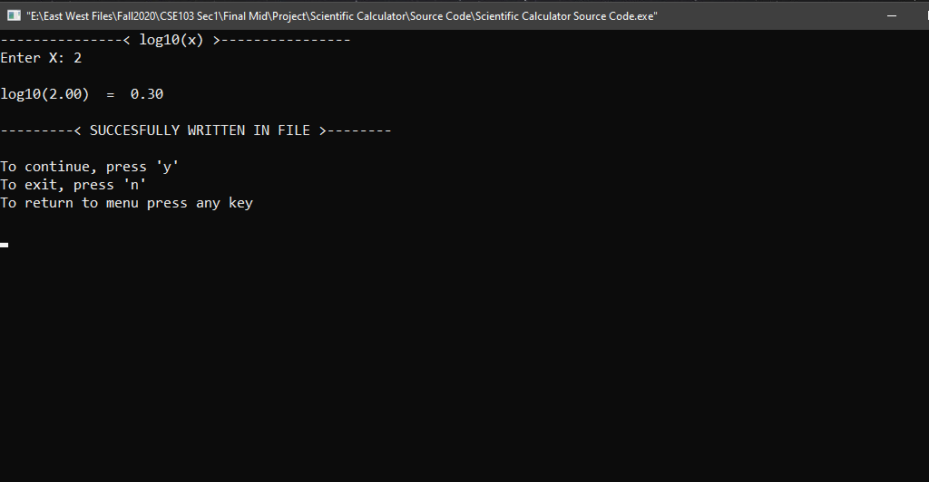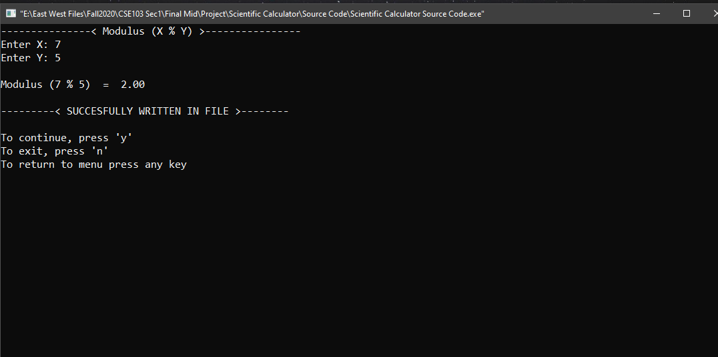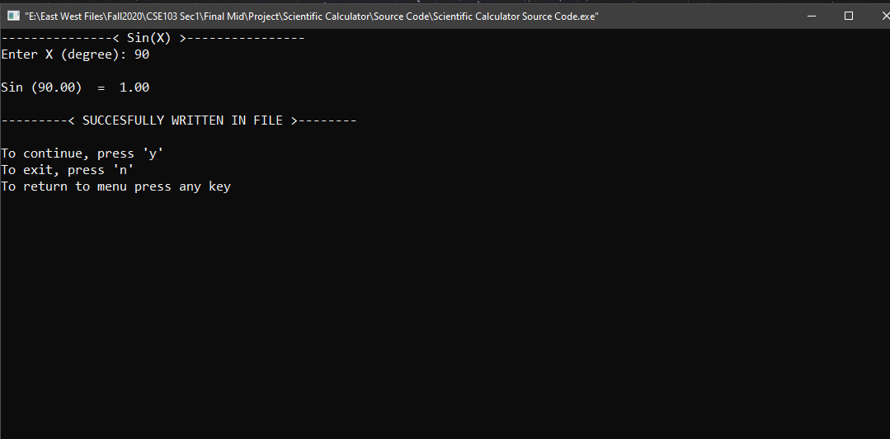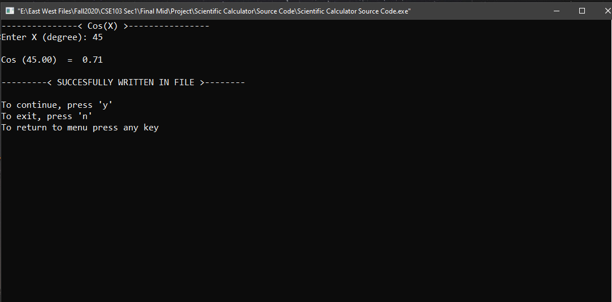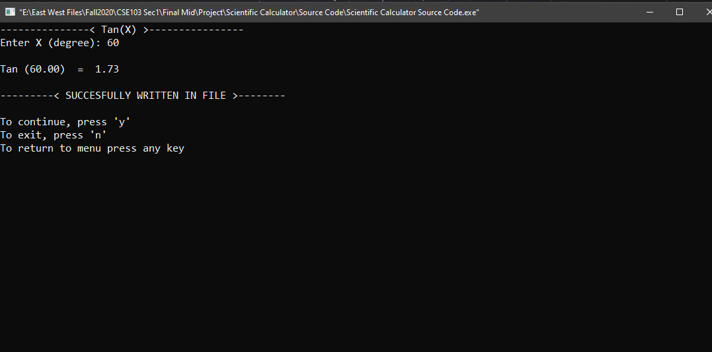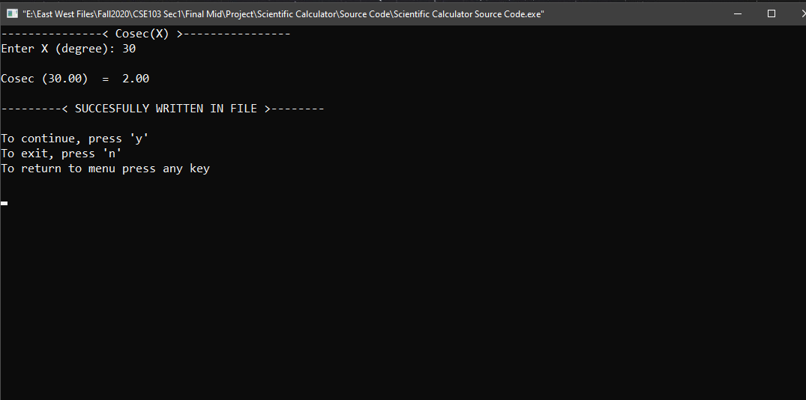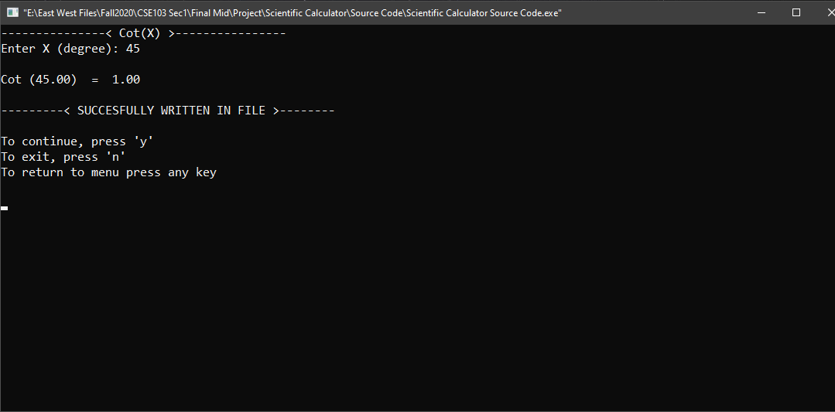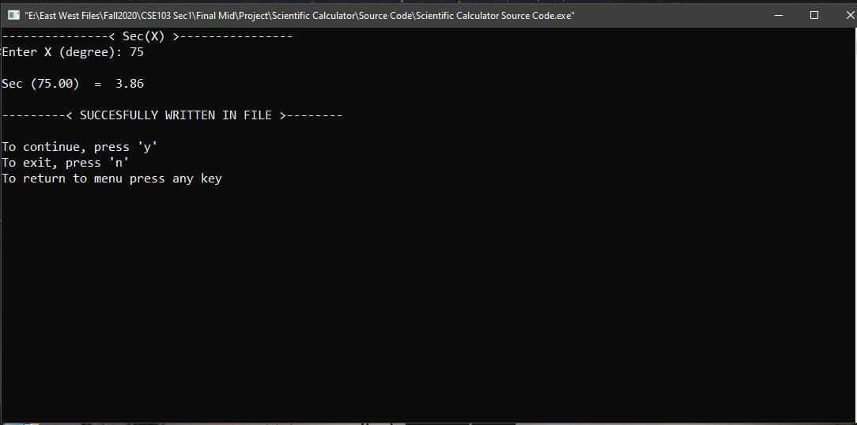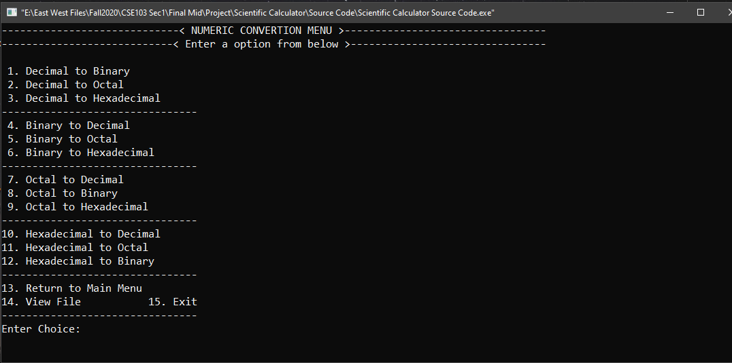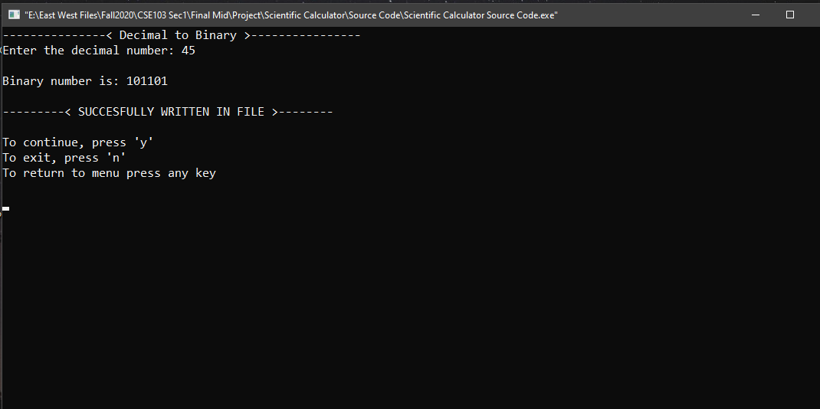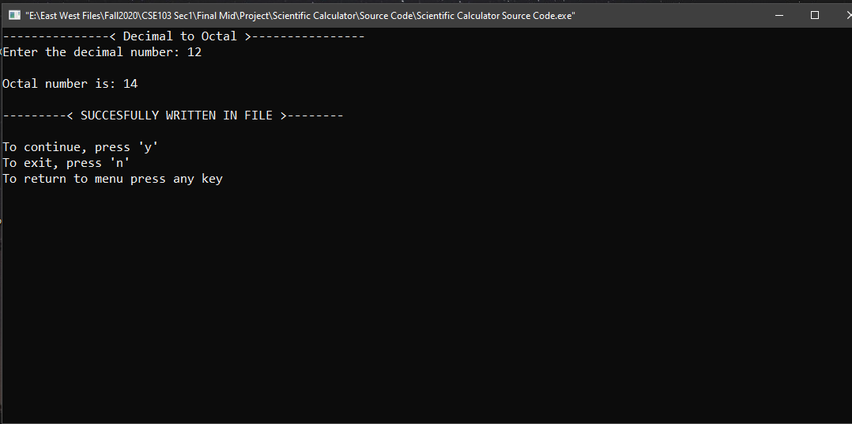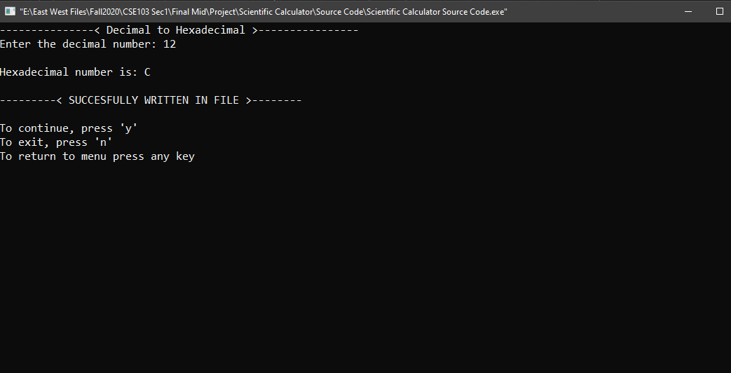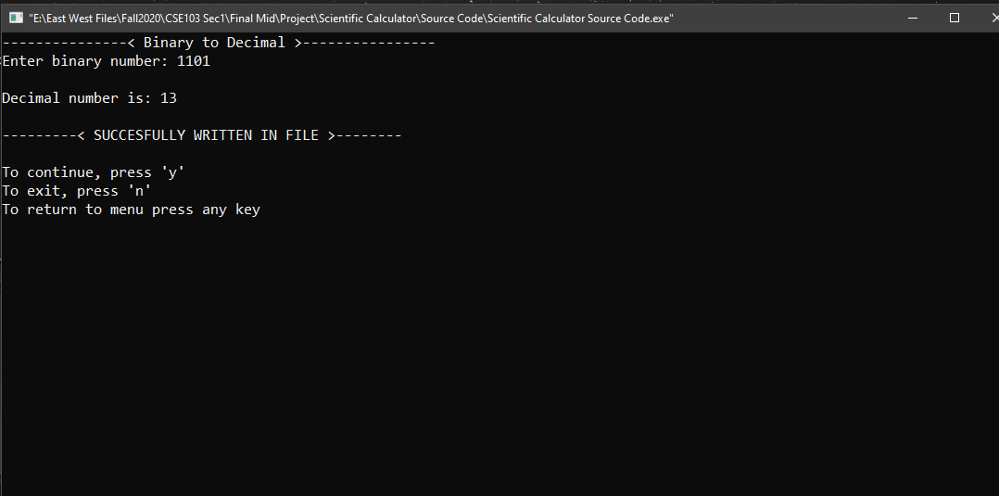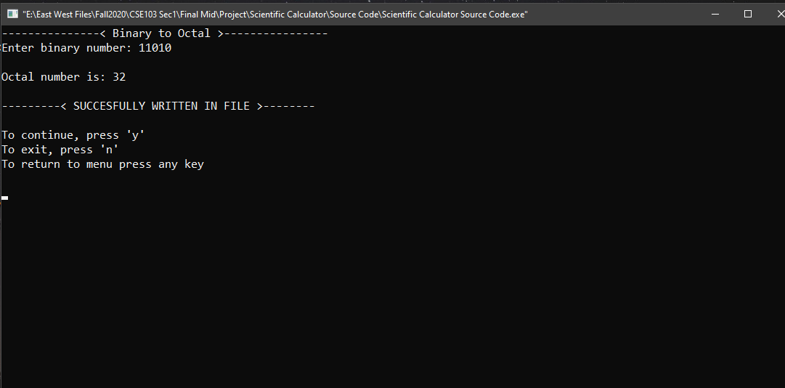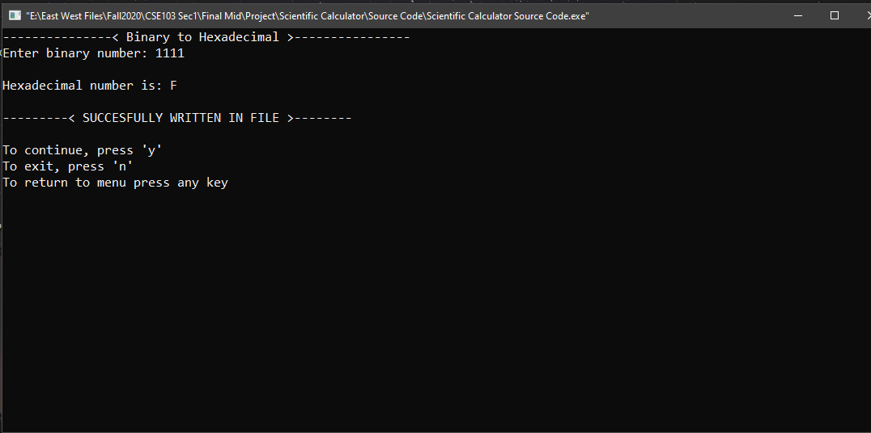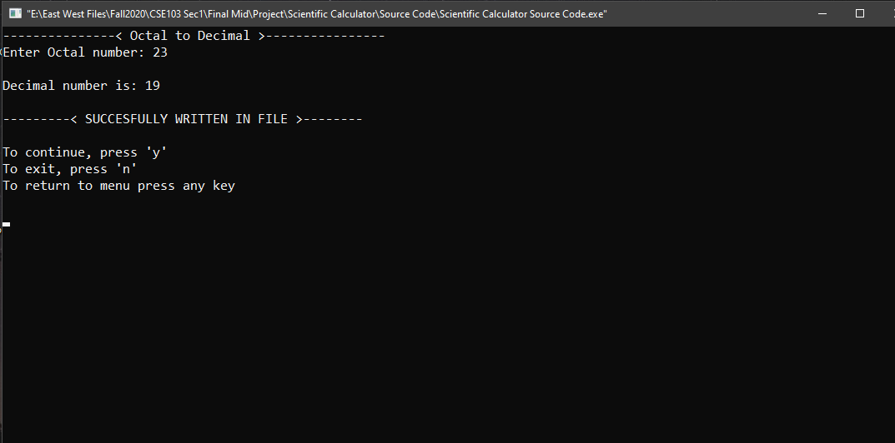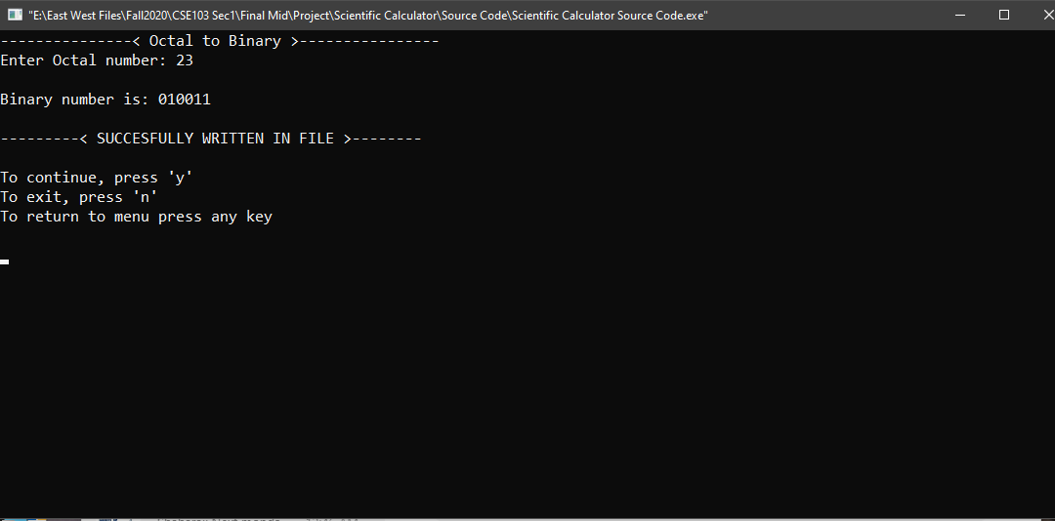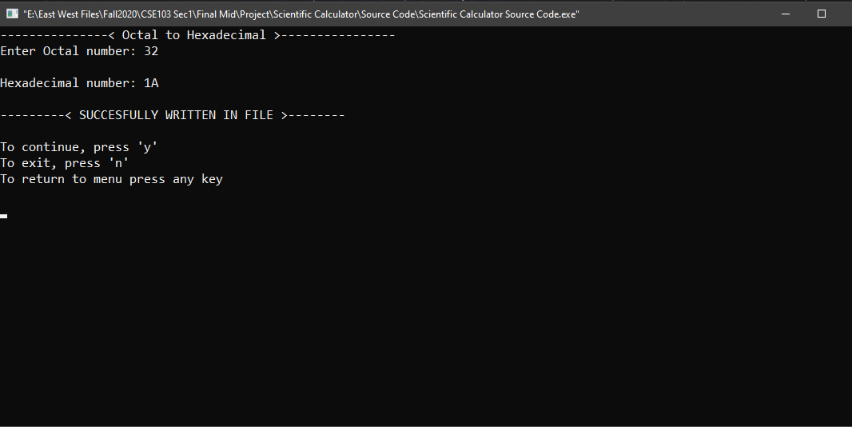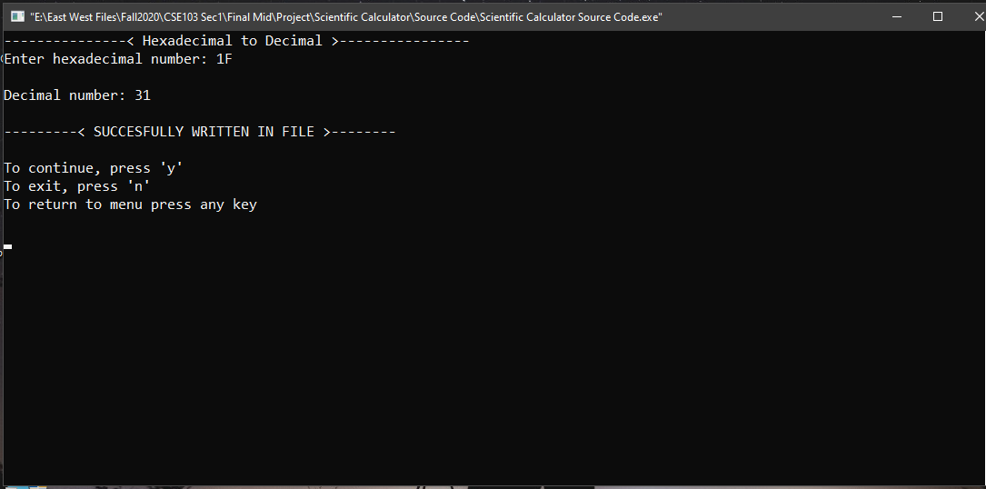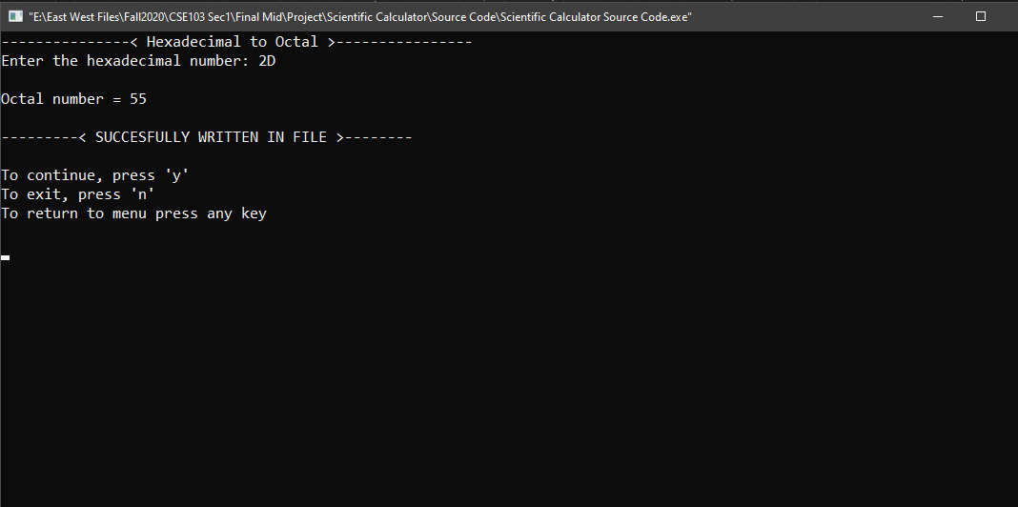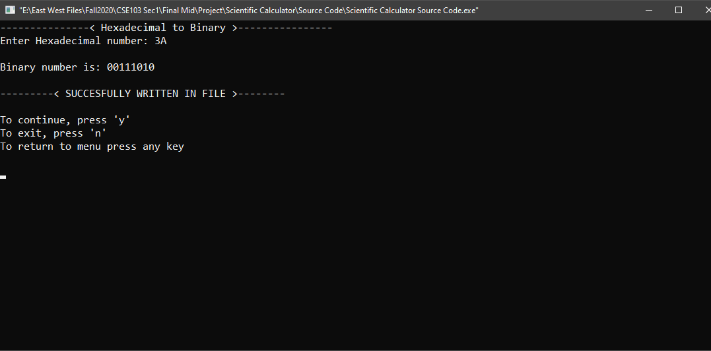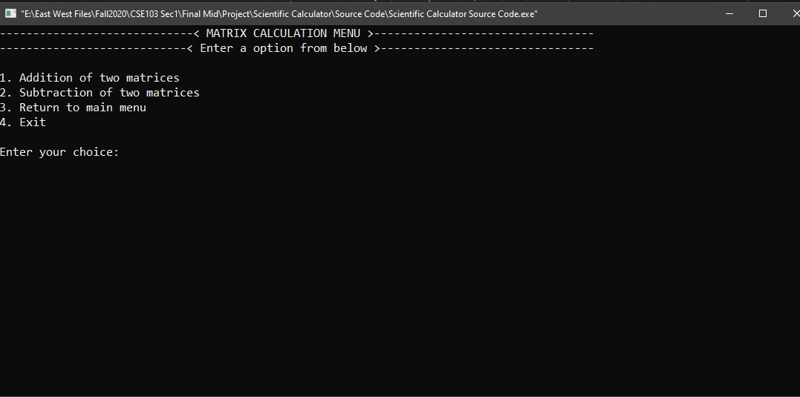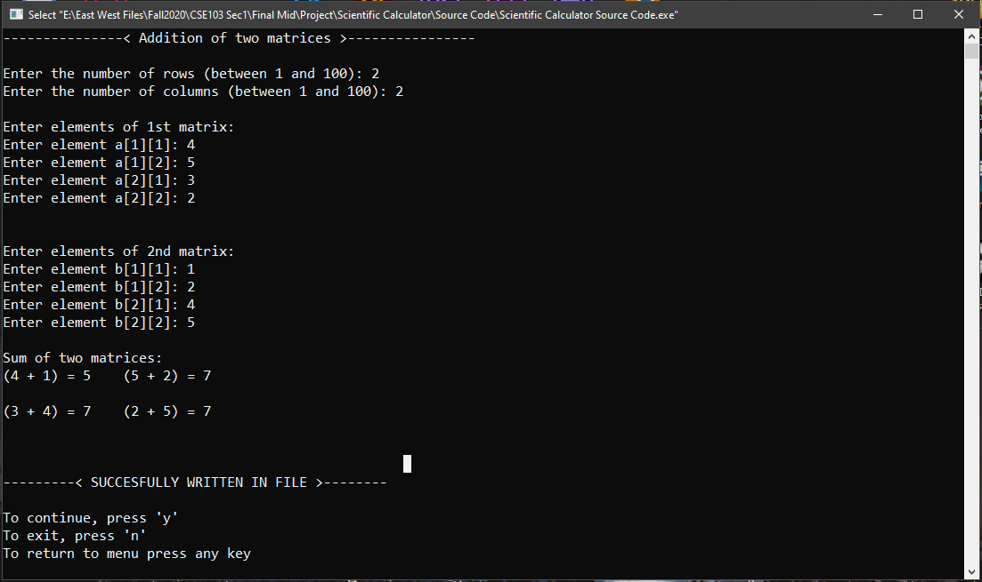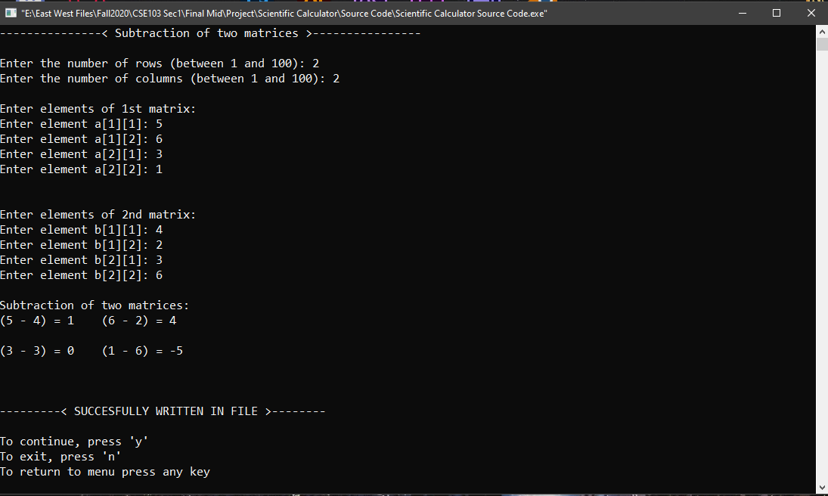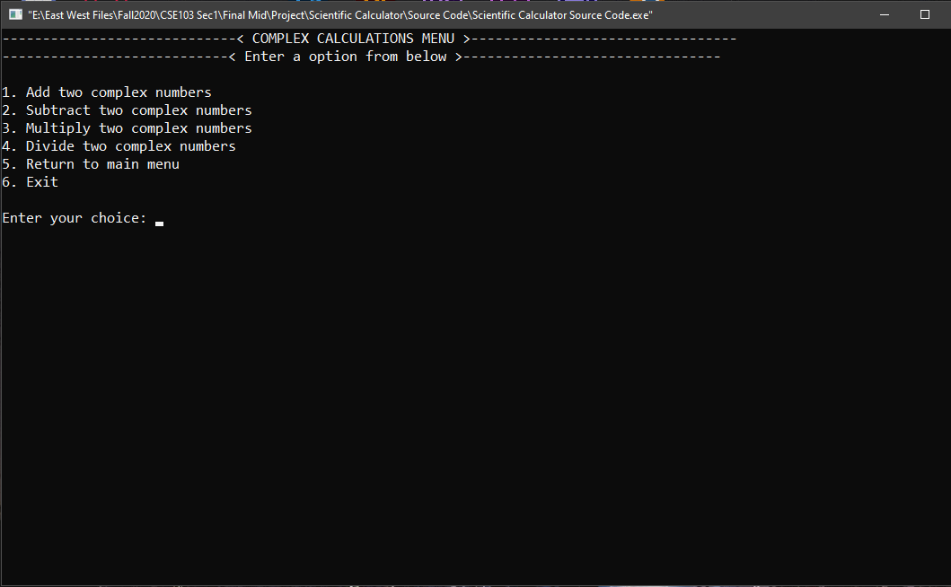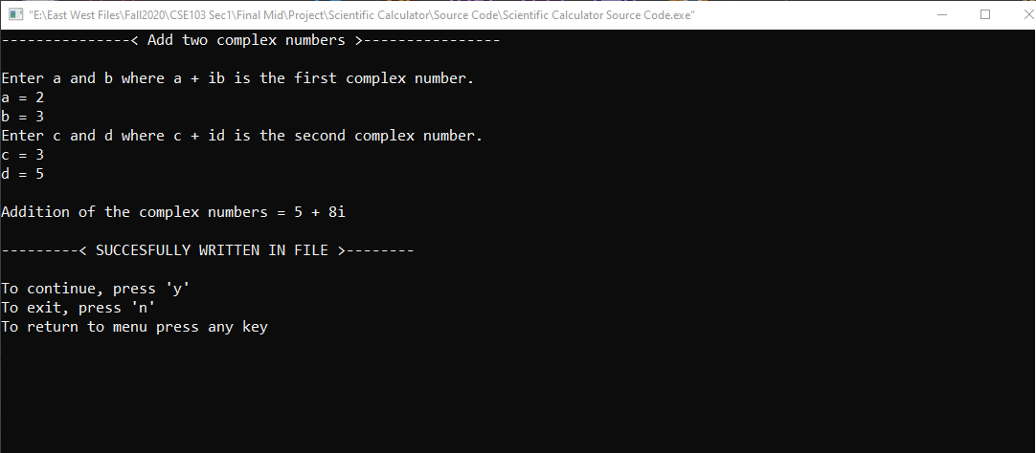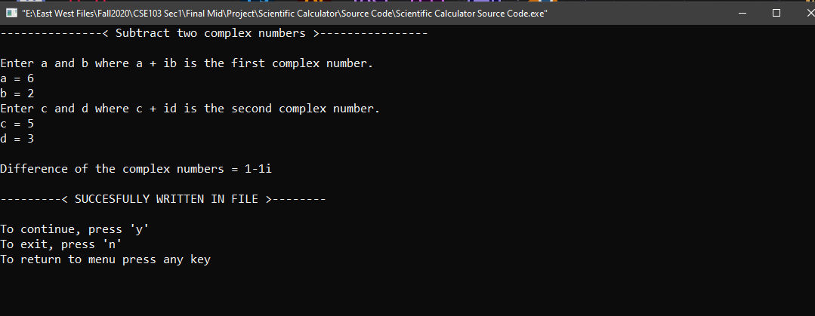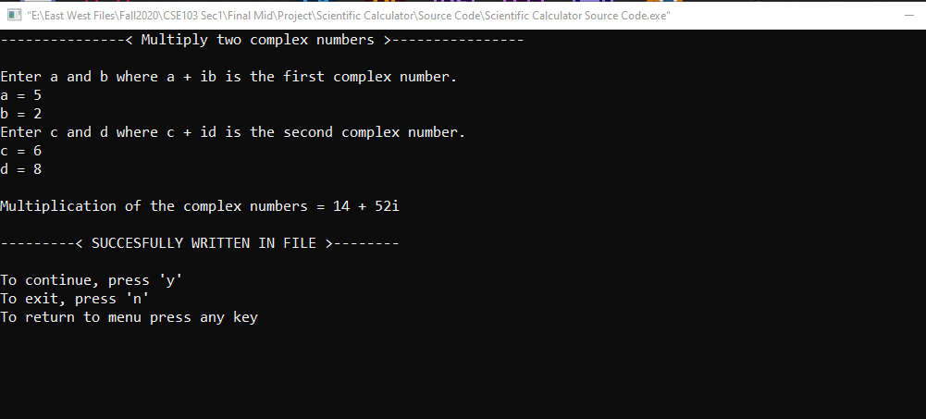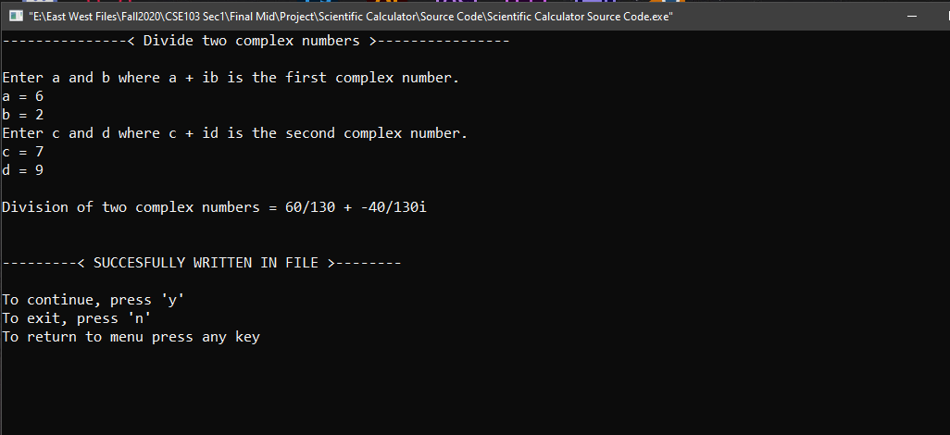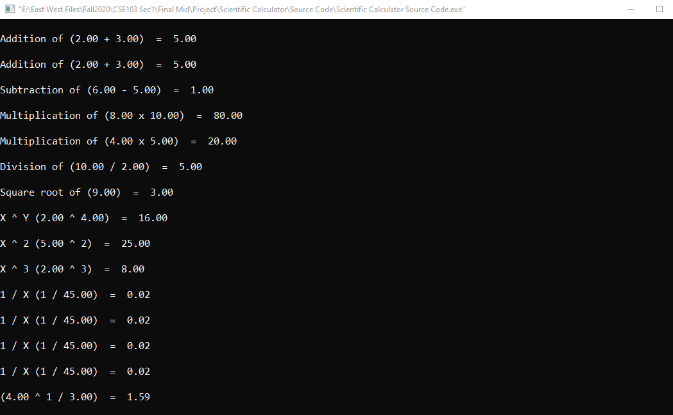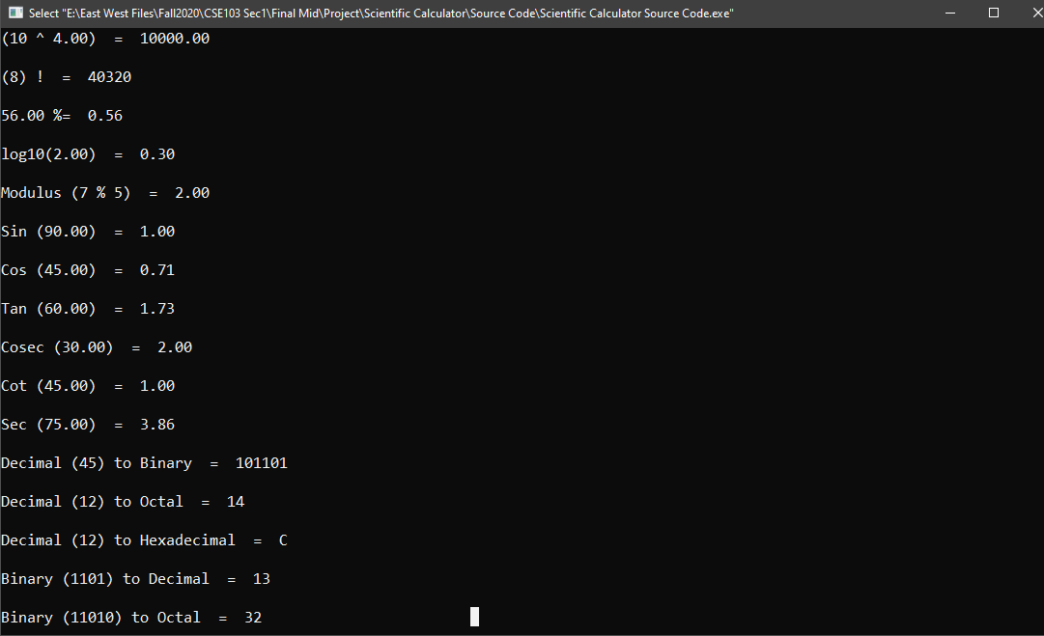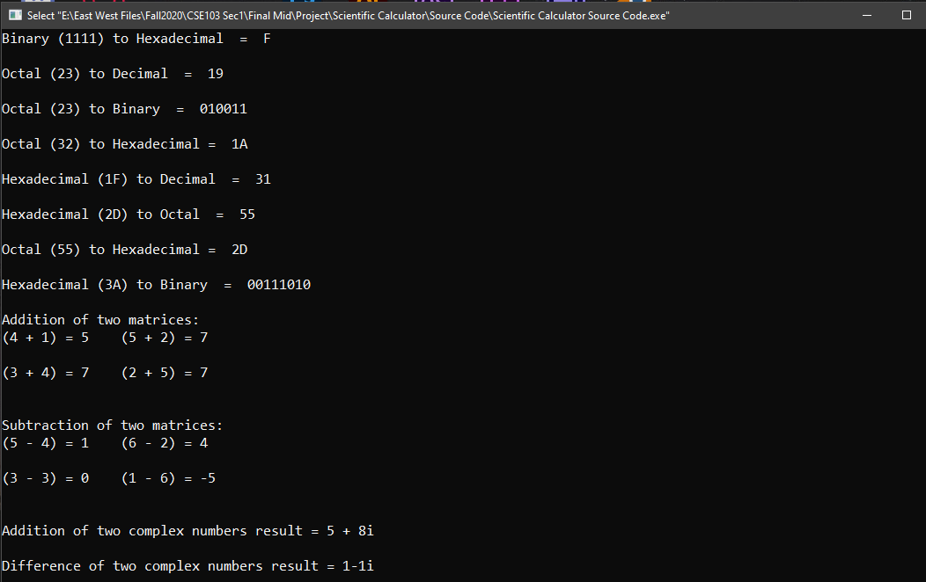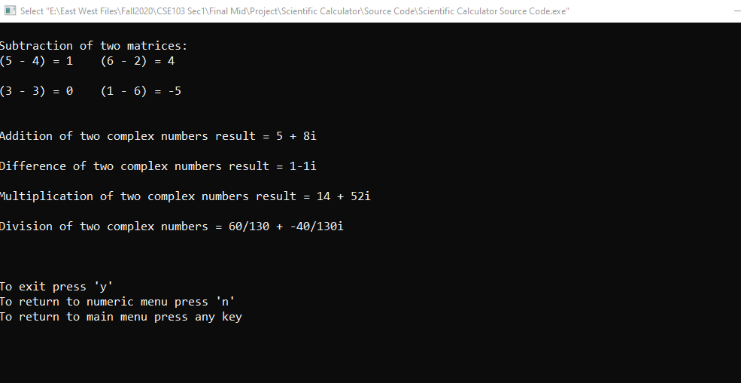

Limitation of our program

Binomial functions, polynomial functions, vector, matrix multiplication, matrix division are the limitations in our project.

APPENDIX

#include<stdio.h>

#include<stdlib.h>

#include<string.h>

#include<math.h>

#include<conio.h>

#include<windows.h>

void menu();

void view();

void add();

void substrct();

void multiply();

void divide();

void squareroot();

void xTowy();

void xTow2();

void xTow3();

void oneBx();

void xTowOneBy();

void xTowYbY();

void tenTowx();

void xfac();

void percentage();

void logTenX();

void modul();

void sinx();

void cosx();

void tanx();

void cosecx();

void cotx();

void secx();

void numericSystem();

void deciTobinary();

void deciToOctal();

void deciToHexa();

void binaryTodeci();

void binaryToOctal();

void binaryToHexa();

void octalTodeci();

void octalToBinary();

void octalToHexa();

void hexaTodeci();

void hexaToOctal();

void hexaToBinary();

void matrixmenu();

void addmatrix();

void submatrix();

void complexmenu();

struct complex

{

int real, img;

};

void addcomplex();

void subcomplex();

void mulcomplex();

void divcomplex();

int main()

{

printf("\t\t\t---------------< SCIENTIFIC CALCULATOR >----------------\n");

printf("\t\t\t-------------< Press any key to continue >--------------\n");

getch();

menu();

}

void menu()

{

fflush(stdin);

int choice;

system("cls");

printf("---------------------------------< MENU >-------------------------------------\n");

printf("-----------------------< Enter a option from below >--------------------------\n\n");

printf("1. Addition\t 2. Subtraction\t\t 3. Multiplication\t 4. Division\n\n");

printf("5. Square root\t 6. X ^ Y\t\t 7. X ^ 2\t\t 8. X ^ 3\n\n");

printf("9. 1 / X\t 10. X ^ (1 / Y)\t 11. X ^ (Y1 / Y2)\t 12. 10 ^ X\n\n");

printf("13. X !\t\t 14. X %%\t\t 15. log10(x)\t\t 16. Modulus\n\n");

printf("17. Sin(X)\t 18. Cos(X)\t\t 19. Tan(X)\t\t 20. Cosec(X)\n\n");

printf("21. Cot(X)\t 22. Sec(X)\t\t 23. Numeric Convertion Menu\n\n");

printf("24. Matrix Calculation Menu\t\t25. Complex Calculations Menu\n");

printf("-------------------------------------------------------------------------------------------\n");

printf("26. View File\t\t 27. Exit\n");

printf("-------------------------------------------------------------------------------------------\n");

printf("Enter Choice: ");

scanf("%d", &choice);

fflush(stdin);

switch(choice)

{

case 1:

add();

break;

case 2:

substrct();

break;

case 3:

multiply();

break;

case 4:

divide();

break;

case 5:

squareroot();

break;

case 6:

xTowy();

break;

case 7:

xTow2();

break;

case 8:

xTow3();

break;

case 9:

oneBx();

break;

case 10:

xTowOneBy();

break;

case 11:

xTowYbY();

break;

case 12:

tenTowx();

break;

case 13:

xfac();

break;

case 14:

percentage();

break;

case 15:

logTenX();

break;

case 16:

modul();

break;

case 17:

sinx();

break;

case 18:

cosx();

break;

case 19:

tanx();

break;

case 20:

cosecx();

break;

case 21:

cotx();

break;

case 22:

secx();

break;

case 23:

numericSystem();

break;

case 24:

matrixmenu();

break;

case 25:

complexmenu();

break;

case 27:

exit(1);

break;

case 26:

view();

break;

}

}

void view()

{

system("cls");

FILE *fp;

fp = fopen("results.txt","r");

char temp[10000];

char choice;

fgets(temp, sizeof(temp), fp);

while(!feof(fp))

{

printf("%s", temp);

fgets(temp, sizeof(temp), fp);

}

printf("\n\nTo exit press 'y'\nTo return to numeric menu press 'n'\nTo return to main menu press any key");

choice = getch();

if(choice == 'y')

{

exit(1);

}

else if(choice == 'n')

{

numericSystem();

}

else

{

menu();

}

}

void add()

{

system("cls");

FILE *fp;

fp = fopen("results.txt","a");

double x, y, sum;

char choice;

printf("---------------< Addition >----------------\n");

printf("Enter X: ");

scanf("%lf", &x);

printf("Enter Y: ");

scanf("%lf", &y);

sum = x + y;

printf("\nAddition of (%.2f + %.2f) = %.2f\n\n", x, y, sum);

fprintf(fp,"Addition of (%.2f + %.2f) = %.2f\n\n", x, y, sum);

printf("---------< SUCCESFULLY WRITTEN IN FILE >--------\n");

fclose(fp);

printf("\nTo continue, press 'y'\nTo exit, press 'n'\nTo return to menu press any key\n\n");

choice = getch();

if(choice == 'y')

{

add();

}

else if(choice == 'n')

{

exit(1);

}

else

{

menu();

}

}

void substrct()

{

system("cls");

FILE *fp;

fp = fopen("results.txt","a");

double x, y, sum;

char choice;

printf("---------------< Subtraction >----------------\n");

printf("Enter X: ");

scanf("%lf", &x);

printf("Enter Y: ");

scanf("%lf", &y);

sum = x - y;

printf("\nSubtraction of (%.2f - %.2f) = %.2f\n\n", x, y, sum);

fprintf(fp,"Subtraction of (%.2f - %.2f) = %.2f\n\n", x, y, sum);

printf("---------< SUCCESFULLY WRITTEN IN FILE >--------\n");

fclose(fp);

printf("\nTo continue, press 'y'\nTo exit, press 'n'\nTo return to menu press any key\n\n");

choice = getch();

if(choice == 'y')

{

substrct();

}

else if(choice == 'n')

{

exit(1);

}

else

{

menu();

}

}

void multiply()

{

system("cls");

FILE *fp;

fp = fopen("results.txt","a");

double x, y, sum;

char choice;

printf("---------------< Multiplication >----------------\n");

printf("Enter X: ");

scanf("%lf", &x);

printf("Enter Y: ");

scanf("%lf", &y);

sum = x * y;

printf("\nMultiplication of (%.2f x %.2f) = %.2f\n\n", x, y, sum);

fprintf(fp,"Multiplication of (%.2f x %.2f) = %.2f\n\n", x, y, sum);

printf("---------< SUCCESFULLY WRITTEN IN FILE >--------\n");

fclose(fp);

printf("\nTo continue, press 'y'\nTo exit, press 'n'\nTo return to menu press any key\n\n");

choice = getch();

if(choice == 'y')

{

multiply();

}

else if(choice == 'n')

{

exit(1);

}

else

{

menu();

}

}

void divide()

{

system("cls");

FILE *fp;

fp = fopen("results.txt","a");

double x, y, sum;

char choice;

printf("---------------< Division >----------------\n");

printf("Enter X: ");

scanf("%lf", &x);

printf("Enter Y: ");

scanf("%lf", &y);

sum = x / y;

printf("\nDivision of (%.2f / %.2f) = %.2f\n\n", x, y, sum);

fprintf(fp,"Division of (%.2f / %.2f) = %.2f\n\n", x, y, sum);

printf("---------< SUCCESFULLY WRITTEN IN FILE >--------\n");

fclose(fp);

printf("\nTo continue, press 'y'\nTo exit, press 'n'\nTo return to menu press any key\n\n");

choice = getch();

if(choice == 'y')

{

divide();

}

else if(choice == 'n')

{

exit(1);

}

else

{

menu();

}

}

void squareroot()

{

system("cls");

FILE *fp;

fp = fopen("results.txt","a");

fflush(stdin);

double x, y, sum;

char choice;

printf("---------------< Square Root >----------------\n");

printf("Enter X: ");

scanf("%lf", &x);

sum = sqrt(x);

printf("\nSquare root of (%.2f) = %.2f\n\n", x, sum);

fprintf(fp,"Square root of (%.2f) = %.2f\n\n", x, sum);

printf("---------< SUCCESFULLY WRITTEN IN FILE >--------\n");

fclose(fp);

printf("\nTo continue, press 'y'\nTo exit, press 'n'\nTo return to menu press any key\n\n");

choice = getch();

if(choice == 'y')

{

squareroot();

}

else if(choice == 'n')

{

exit(1);

}

else

{

menu();

}

}

void xTowy()

{

system("cls");

FILE *fp;

fp = fopen("results.txt","a");

double x, y, sum;

char choice;

printf("---------------< X ^ Y >----------------\n");

printf("Enter X: ");

scanf("%lf", &x);

printf("Enter Y: ");

scanf("%lf", &y);

sum = pow (x, y);

printf("\n(%.2f ^ %.2f) = %.2f\n\n", x, y, sum);

fprintf(fp,"X ^ Y (%.2f ^ %.2f) = %.2f\n\n", x, y, sum);

printf("---------< SUCCESFULLY WRITTEN IN FILE >--------\n");

fclose(fp);

printf("\nTo continue, press 'y'\nTo exit, press 'n'\nTo return to menu press any key\n\n");

choice = getch();

if(choice == 'y')

{

xTowy();

}

else if(choice == 'n')

{

exit(1);

}

else

{

menu();

}

}

void xTow2()

{

system("cls");

FILE *fp;

fp = fopen("results.txt","a");

double x, sum;

char choice;

printf("---------------< X ^ 2 >----------------\n");

printf("Enter X: ");

scanf("%lf", &x);

sum = pow (x, 2);

printf("\n(%.2f ^ 2) = %.2f\n\n", x, sum);

fprintf(fp,"X ^ 2 (%.2f ^ 2) = %.2f\n\n", x, sum);

printf("---------< SUCCESFULLY WRITTEN IN FILE >--------\n");

fclose(fp);

printf("\nTo continue, press 'y'\nTo exit, press 'n'\nTo return to menu press any key\n\n");

choice = getch();

if(choice == 'y')

{

xTow2();

}

else if(choice == 'n')

{

exit(1);

}

else

{

menu();

}

}

void xTow3()

{

system("cls");

FILE *fp;

fp = fopen("results.txt","a");

double x, sum;

char choice;

printf("---------------< X ^ 3 >----------------\n");

printf("Enter X: ");

scanf("%lf", &x);

sum = pow (x, 3);

printf("\n(%.2f ^ 3) = %.2f\n\n", x, sum);

fprintf(fp,"X ^ 3 (%.2f ^ 3) = %.2f\n\n", x, sum);

printf("---------< SUCCESFULLY WRITTEN IN FILE >--------\n");

fclose(fp);

printf("\nTo continue, press 'y'\nTo exit, press 'n'\nTo return to menu press any key\n\n");

choice = getch();

if(choice == 'y')

{

xTow3();

}

else if(choice == 'n')

{

exit(1);

}

else

{

menu();

}

}

void oneBx()

{

system("cls");

FILE *fp;

fp = fopen("results.txt","a");

double x, sum;

char choice;

printf("---------------< 1 / X >----------------\n");

printf("Enter X: ");

scanf("%lf", &x);

sum = pow (x, -1);

printf("\n(1 / %.2f) = %.2f\n\n", x, sum);

fprintf(fp,"1 / X (1 / %.2f) = %.2f\n\n", x, sum);

printf("---------< SUCCESFULLY WRITTEN IN FILE >--------\n");

fclose(fp);

printf("\nTo continue, press 'y'\nTo exit, press 'n'\nTo return to menu press any key\n\n");

choice = getch();

if(choice == 'y')

{

oneBx();

}

else if(choice == 'n')

{

exit(1);

}

else

{

menu();

}

}

void xTowOneBy()

{

system("cls");

FILE *fp;

fp = fopen("results.txt","a");

double x, y, sum;

char choice;

printf("---------------< X ^ (1 / Y) >----------------\n");

printf("Enter X: ");

scanf("%lf", &x);

printf("Enter Y: ");

scanf("%lf", &y);

sum = pow (x, (1/y));

printf("\n(%.2f ^ 1 / %.2f) = %.2f\n\n", x, y, sum);

fprintf(fp,"(%.2f ^ 1 / %.2f) = %.2f\n\n", x, y, sum);

printf("---------< SUCCESFULLY WRITTEN IN FILE >--------\n");

fclose(fp);

printf("\nTo continue, press 'y'\nTo exit, press 'n'\nTo return to menu press any key\n\n");

choice = getch();

if(choice == 'y')

{

xTowOneBy();

}

else if(choice == 'n')

{

exit(1);

}

else

{

menu();

}

}

void xTowYbY()

{

system("cls");

FILE *fp;

fp = fopen("results.txt","a");

double x, y1, y2, sum;

char choice;

printf("---------------< X ^ (Y1 / Y2) >----------------\n");

printf("Enter X: ");

scanf("%lf", &x);

printf("Enter Y1: ");

scanf("%lf", &y1);

printf("Enter Y2: ");

scanf("%lf", &y2);

sum = pow (x, (y1/y2));

printf("\n(%.2f ^ %.2f / %.2f) = %.2f\n\n", x, y1, y2, sum);

fprintf(fp,"(%.2f ^ %.2f / %.2f) = %.2f\n\n", x, y1, y2, sum);

printf("---------< SUCCESFULLY WRITTEN IN FILE >--------\n");

fclose(fp);

printf("\nTo continue, press 'y'\nTo exit, press 'n'\nTo return to menu press any key\n\n");

choice = getch();

if(choice == 'y')

{

xTowYbY();

}

else if(choice == 'n')

{

exit(1);

}

else

{

menu();

}

}

void tenTowx()

{

system("cls");

FILE *fp;

fp = fopen("results.txt","a");

double x, sum;

char choice;

printf("---------------< 10 ^ X >----------------\n");

printf("Enter X: ");

scanf("%lf", &x);

sum = pow (10, x);

printf("\n(10 ^ %.2f) = %.2f\n\n", x, sum);

fprintf(fp,"(10 ^ %.2f) = %.2f\n\n", x, sum);

printf("---------< SUCCESFULLY WRITTEN IN FILE >--------\n");

fclose(fp);

printf("\nTo continue, press 'y'\nTo exit, press 'n'\nTo return to menu press any key\n\n");

choice = getch();

if(choice == 'y')

{

tenTowx();

}

else if(choice == 'n')

{

exit(1);

}

else

{

menu();

}

}

void xfac()

{

system("cls");

FILE *fp;

fp = fopen("results.txt","a");

int i;

long long x, sum;

char choice;

printf("---------------< X ! >----------------\n");

printf("Enter X: ");

scanf("%lld", &x);

sum = 1;

for(i=1; i<=x; i++)

{

sum = sum * i;

}

printf("\n(%lld) ! = %lld\n\n", x, sum);

fprintf(fp,"(%lld) ! = %lld\n\n", x, sum);

printf("---------< SUCCESFULLY WRITTEN IN FILE >--------\n");

fclose(fp);

printf("\nTo continue, press 'y'\nTo exit, press 'n'\nTo return to menu press any key\n\n");

choice = getch();

if(choice == 'y')

{

xfac();

}

else if(choice == 'n')

{

exit(1);

}

else

{

menu();

}

}

void percentage()

{

system("cls");

FILE *fp;

fp = fopen("results.txt","a");

int i;

double x, sum;

char choice;

printf("---------------< X % >----------------\n");

printf("Enter X: ");

scanf("%lf", &x);

sum = x / 100;

printf("\n%.2f %% = %.2f\n\n", x, sum);

fprintf(fp, "%.2f %%= %.2f\n\n", x, sum);

printf("---------< SUCCESFULLY WRITTEN IN FILE >--------\n");

fclose(fp);

printf("\nTo continue, press 'y'\nTo exit, press 'n'\nTo return to menu press any key\n\n");

choice = getch();

if(choice == 'y')

{

percentage();

}

else if(choice == 'n')

{

exit(1);

}

else

{

menu();

}

}

void logTenX()

{

system("cls");

FILE *fp;

fp = fopen("results.txt","a");

int i;

double x, sum;

char choice;

printf("---------------< log10(x) >----------------\n");

printf("Enter X: ");

scanf("%lf", &x);

sum = log10(x);

printf("\nlog10(%.2f) = %.2f\n\n", x, sum);

fprintf(fp, "log10(%.2f) = %.2f\n\n", x, sum);

printf("---------< SUCCESFULLY WRITTEN IN FILE >--------\n");

fclose(fp);

printf("\nTo continue, press 'y'\nTo exit, press 'n'\nTo return to menu press any key\n\n");

choice = getch();

if(choice == 'y')

{

logTenX();

}

else if(choice == 'n')

{

exit(1);

}

else

{

menu();

}

}

void modul()

{

system("cls");

FILE *fp;

fp = fopen("results.txt","a");

int i, x, y;

double sum;

char choice;

printf("---------------< Modulus (X %% Y) >----------------\n");

printf("Enter X: ");

scanf("%d", &x);

printf("Enter Y: ");

scanf("%d", &y);

sum = x % y;

printf("\nModulus (%d %% %d) = %.2f\n\n", x, y, sum);

fprintf(fp, "Modulus (%d %% %d) = %.2f\n\n", x, y, sum);

printf("---------< SUCCESFULLY WRITTEN IN FILE >--------\n");

fclose(fp);

printf("\nTo continue, press 'y'\nTo exit, press 'n'\nTo return to menu press any key\n\n");

choice = getch();

if(choice == 'y')

{

modul();

}

else if(choice == 'n')

{

exit(1);

}

else

{

menu();

}

}

void sinx()

{

system("cls");

FILE *fp;

fp = fopen("results.txt","a");

int i;

double x, sum;

char choice;

printf("---------------< Sin(X) >----------------\n");

printf("Enter X (degree): ");

scanf("%lf", &x);

sum = sin(x * 3.14159 / 180);

printf("\nSin (%.2f) = %.2f\n\n", x, sum);

fprintf(fp, "Sin (%.2f) = %.2f\n\n", x, sum);

printf("---------< SUCCESFULLY WRITTEN IN FILE >--------\n");

fclose(fp);

printf("\nTo continue, press 'y'\nTo exit, press 'n'\nTo return to menu press any key\n\n");

choice = getch();

if(choice == 'y')

{

sinx();

}

else if(choice == 'n')

{

exit(1);

}

else

{

menu();

}

}

void cosx()

{

system("cls");

FILE *fp;

fp = fopen("results.txt","a");

int i;

double x, sum;

char choice;

printf("---------------< Cos(X) >----------------\n");

printf("Enter X (degree): ");

scanf("%lf", &x);

sum = cos(x * 3.14159 / 180);

printf("\nCos (%.2f) = %.2f\n\n", x, sum);

fprintf(fp, "Cos (%.2f) = %.2f\n\n", x, sum);

printf("---------< SUCCESFULLY WRITTEN IN FILE >--------\n");

fclose(fp);

printf("\nTo continue, press 'y'\nTo exit, press 'n'\nTo return to menu press any key\n\n");

choice = getch();

if(choice == 'y')

{

cosx();

}

else if(choice == 'n')

{

exit(1);

}

else

{

menu();

}

}

void tanx()

{

system("cls");

FILE *fp;

fp = fopen("results.txt","a");

int i;

double x, sum;

char choice;

printf("---------------< Tan(X) >----------------\n");

printf("Enter X (degree): ");

scanf("%lf", &x);

sum = tan(x * 3.14159 / 180);

printf("\nTan (%.2f) = %.2f\n\n", x, sum);

fprintf(fp, "Tan (%.2f) = %.2f\n\n", x, sum);

printf("---------< SUCCESFULLY WRITTEN IN FILE >--------\n");

fclose(fp);

printf("\nTo continue, press 'y'\nTo exit, press 'n'\nTo return to menu press any key\n\n");

choice = getch();

if(choice == 'y')

{

tanx();

}

else if(choice == 'n')

{

exit(1);

}

else

{

menu();

}

}

void cosecx()

{

system("cls");

FILE *fp;

fp = fopen("results.txt","a");

int i;

double x, sum;

char choice;

printf("---------------< Cosec(X) >----------------\n");

printf("Enter X (degree): ");

scanf("%lf", &x);

sum = 1 / sin(x * 3.14159 / 180);

printf("\nCosec (%.2f) = %.2f\n\n", x, sum);

fprintf(fp, "Cosec (%.2f) = %.2f\n\n", x, sum);

printf("---------< SUCCESFULLY WRITTEN IN FILE >--------\n");

fclose(fp);

printf("\nTo continue, press 'y'\nTo exit, press 'n'\nTo return to menu press any key\n\n");

choice = getch();

if(choice == 'y')

{

cosecx();

}

else if(choice == 'n')

{

exit(1);

}

else

{

menu();

}

}

void cotx()

{

system("cls");

FILE *fp;

fp = fopen("results.txt","a");

int i;

double x, sum;

char choice;

printf("---------------< Cot(X) >----------------\n");

printf("Enter X (degree): ");

scanf("%lf", &x);

sum = 1 / tan(x * 3.14159 / 180);

printf("\nCot (%.2f) = %.2f\n\n", x, sum);

fprintf(fp, "Cot (%.2f) = %.2f\n\n", x, sum);

printf("---------< SUCCESFULLY WRITTEN IN FILE >--------\n");

fclose(fp);

printf("\nTo continue, press 'y'\nTo exit, press 'n'\nTo return to menu press any key\n\n");

choice = getch();

if(choice == 'y')

{

cotx();

}

else if(choice == 'n')

{

exit(1);

}

else

{

menu();

}

}

void secx()

{

system("cls");

FILE *fp;

fp = fopen("results.txt","a");

int i;

double x, sum;

char choice;

printf("---------------< Sec(X) >----------------\n");

printf("Enter X (degree): ");

scanf("%lf", &x);

sum = 1 / cos(x * 3.14159 / 180);

printf("\nSec (%.2f) = %.2f\n\n", x, sum);

fprintf(fp, "Sec (%.2f) = %.2f\n\n", x, sum);

printf("---------< SUCCESFULLY WRITTEN IN FILE >--------\n");

fclose(fp);

printf("\nTo continue, press 'y'\nTo exit, press 'n'\nTo return to menu press any key\n\n");

choice = getch();

if(choice == 'y')

{

secx();

}

else if(choice == 'n')

{

exit(1);

}

else

{

menu();

}

}

void numericSystem()

{

fflush(stdin);

int choice;

system("cls");

printf("-----------------------------< NUMERIC CONVERTION MENU >---------------------------------\n");

printf("----------------------------< Enter a option from below >--------------------------------\n\n");

printf(" 1. Decimal to Binary\n 2. Decimal to Octal\n 3. Decimal to Hexadecimal\n");

printf("--------------------------------\n");

printf(" 4. Binary to Decimal\n 5. Binary to Octal\n 6. Binary to Hexadecimal\n");

printf("--------------------------------\n");

printf(" 7. Octal to Decimal\n 8. Octal to Binary\n 9. Octal to Hexadecimal\n");

printf("--------------------------------\n");

printf("10. Hexadecimal to Decimal\n11. Hexadecimal to Octal\n12. Hexadecimal to Binary\n");

printf("--------------------------------\n");

printf("13. Return to Main Menu\n14. View File\t\t15. Exit\n");

printf("--------------------------------\n");

printf("Enter Choice: ");

scanf("%d", &choice);

switch(choice)

{

case 13:

menu();

break;

case 14:

view();

break;

case 15:

exit(1);

break;

case 1:

deciTobinary();

break;

case 2:

deciToOctal();

break;

case 3:

deciToHexa();

break;

case 4:

binaryTodeci();

break;

case 5:

binaryToOctal();

break;

case 6:

binaryToHexa();

break;

case 7:

octalTodeci();

break;

case 8:

octalToBinary();

break;

case 9:

octalToHexa();

break;

case 10:

hexaTodeci();

break;

case 11:

hexaToOctal();

break;

case 12:

hexaToBinary();

break;

}

}

void deciTobinary()

{

system("cls");

FILE *fp;

fp = fopen("results.txt","a");

long int rem[50];

long int num, i = 0, length = 0, store;

char choice;

printf("---------------< Decimal to Binary >----------------\n");

printf("Enter the decimal number: ");

scanf("%ld", &num);

store = num;

while(num>0)

{

rem[i] = num % 2;

num = num / 2;

i++;

length++;

}

printf("\nBinary number is: ");

fprintf(fp,"Decimal (%ld) to Binary = ",store);

for(i = length - 1; i >=0; i--)

{

printf("%ld", rem[i]);

fprintf(fp,"%ld", rem[i]);

}

fprintf(fp,"\n\n");

printf("\n\n---------< SUCCESFULLY WRITTEN IN FILE >--------\n");

fclose(fp);

printf("\nTo continue, press 'y'\nTo exit, press 'n'\nTo return to menu press any key\n\n");

choice = getch();

if(choice == 'y')

{

deciTobinary();

}

else if(choice == 'n')

{

exit(1);

}

else

{

numericSystem();

}

}

void deciToOctal()

{

system("cls");

FILE *fp;

fp = fopen("results.txt","a");

long int rem[50];

long int num, i = 0, length = 0, store;

char choice;

printf("---------------< Decimal to Octal >----------------\n");

printf("Enter the decimal number: ");

scanf("%ld", &num);

store = num;

while(num>0)

{

rem[i] = num % 8;

num = num / 8;

i++;

length++;

}

printf("\nOctal number is: ");

fprintf(fp,"Decimal (%ld) to Octal = ",store);

for(i = length - 1; i >=0; i--)

{

printf("%ld", rem[i]);

fprintf(fp,"%ld", rem[i]);

}

fprintf(fp,"\n\n");

printf("\n\n---------< SUCCESFULLY WRITTEN IN FILE >--------\n");

fclose(fp);

printf("\nTo continue, press 'y'\nTo exit, press 'n'\nTo return to menu press any key\n\n");

choice = getch();

if(choice == 'y')

{

deciToOctal();

}

else if(choice == 'n')

{

exit(1);

}

else

{

numericSystem();

}

}

void deciToHexa()

{

system("cls");

FILE *fp;

fp = fopen("results.txt","a");

long int rem[50];

long int num, i = 0, length = 0, store;

char choice;

printf("---------------< Decimal to Hexadecimal >----------------\n");

printf("Enter the decimal number: ");

scanf("%ld", &num);

store = num;

while(num>0)

{

rem[i] = num % 16;

num = num / 16;

i++;

length++;

}

printf("\nHexadecimal number is: ");

fprintf(fp,"Decimal (%ld) to Hexadecimal = ",store);

for(i = length - 1; i >=0; i--)

{

switch(rem[i])

{

case 10:

printf("A");

fprintf(fp,"A");

break;

case 11:

printf("B");

fprintf(fp,"B");

break;

case 12:

printf("C");

fprintf(fp,"C");

break;

case 13:

printf("D");

fprintf(fp,"D");

break;

case 14:

printf("E");

fprintf(fp,"E");

break;

case 15:

printf("F");

fprintf(fp,"F");

break;

default:

printf("%ld", rem[i]);

fprintf(fp,"%ld", rem[i]);

}

}

fprintf(fp,"\n\n");

printf("\n\n---------< SUCCESFULLY WRITTEN IN FILE >--------\n");

fclose(fp);

printf("\nTo continue, press 'y'\nTo exit, press 'n'\nTo return to menu press any key\n\n");

choice = getch();

if(choice == 'y')

{

deciToHexa();

}

else if(choice == 'n')

{

exit(1);

}

else

{

numericSystem();

}

}

void binaryTodeci()

{

system("cls");

FILE *fp;

fp = fopen("results.txt","a");

long int rem;

long int num, deci = 0, base = 1, store;

char choice;

printf("---------------< Binary to Decimal >----------------\n");

printf("Enter binary number: ");

scanf("%ld", &num);

store = num;

while (num > 0)

{

rem = num % 10;

deci = deci + rem * base;

num = num / 10 ;

base = base * 2;

}

printf("\nDecimal number is: %ld", deci);

fprintf(fp,"Binary (%ld) to Decimal = %ld\n\n", store, deci);

printf("\n\n---------< SUCCESFULLY WRITTEN IN FILE >--------\n");

fclose(fp);

printf("\nTo continue, press 'y'\nTo exit, press 'n'\nTo return to menu press any key\n\n");

choice = getch();

if(choice == 'y')

{

binaryTodeci();

}

else if(choice == 'n')

{

exit(1);

}

else

{

numericSystem();

}

}

void binaryToOctal()

{

system("cls");

FILE *fp;

fp = fopen("results.txt","a");

long int num, octal = 0, j = 1, store, remainder;

char choice;

printf("---------------< Binary to Octal >----------------\n");

printf("Enter binary number: ");

scanf("%ld", &num);

store = num;

while (num!=0)

{

remainder = num % 10;

octal = octal + remainder * j;

j = j * 2;

num = num / 10 ;

}

printf("\nOctal number is: %lo", octal);

fprintf(fp,"Binary (%ld) to Octal = %lo\n\n", store, octal);

printf("\n\n---------< SUCCESFULLY WRITTEN IN FILE >--------\n");

fclose(fp);

printf("\nTo continue, press 'y'\nTo exit, press 'n'\nTo return to menu press any key\n\n");

choice = getch();

if(choice == 'y')

{

binaryToOctal();

}

else if(choice == 'n')

{

exit(1);

}

else

{

numericSystem();

}

}

void binaryToHexa()

{

system("cls");

FILE *fp;

fp = fopen("results.txt","a");

long int num, hexa = 0, j = 1, store, remainder;

char choice;

printf("---------------< Binary to Hexadecimal >----------------\n");

printf("Enter binary number: ");

scanf("%ld", &num);

store = num;

while (num!=0)

{

remainder = num % 10;

hexa = hexa + remainder * j;

j = j * 2;

num = num / 10 ;

}

printf("\nHexadecimal number is: %lX", hexa);

fprintf(fp,"Binary (%ld) to Hexadecimal = %lX\n\n", store, hexa);

printf("\n\n---------< SUCCESFULLY WRITTEN IN FILE >--------\n");

fclose(fp);

printf("\nTo continue, press 'y'\nTo exit, press 'n'\nTo return to menu press any key\n\n");

choice = getch();

if(choice == 'y')

{

binaryToHexa();

}

else if(choice == 'n')

{

exit(1);

}

else

{

numericSystem();

}

}

void octalTodeci()

{

system("cls");

FILE *fp;

fp = fopen("results.txt","a");

long int octal, deci = 0, store;

int i = 0;

char choice;

printf("---------------< Octal to Decimal >----------------\n");

printf("Enter Octal number: ");

scanf("%ld", &octal);

store = octal;

while (octal!=0)

{

deci = deci +(octal % 10)* pow(8, i++);

octal = octal / 10;

}

printf("\nDecimal number is: %ld", deci);

fprintf(fp,"Octal (%ld) to Decimal = %ld\n\n", store, deci);

printf("\n\n---------< SUCCESFULLY WRITTEN IN FILE >--------\n");

fclose(fp);

printf("\nTo continue, press 'y'\nTo exit, press 'n'\nTo return to menu press any key\n\n");

choice = getch();

if(choice == 'y')

{

octalTodeci();

}

else if(choice == 'n')

{

exit(1);

}

else

{

numericSystem();

}

}

void octalToBinary()

{

system("cls");

FILE *fp;

fp = fopen("results.txt","a");

long i = 0;

char octalnum[1000], store[1000];

char choice;

printf("---------------< Octal to Binary >----------------\n");

printf("Enter Octal number: ");

scanf("%s", &octalnum);

printf("\nBinary number is: ");

fprintf(fp,"Octal (%s) to Binary = ", octalnum);

while (octalnum[i])

{

switch(octalnum[i])

{

case '0':

printf("000");

fprintf(fp,"000");

break;

case '1':

printf("001");

fprintf(fp,"001");

break;

case '2':

printf("010");

fprintf(fp,"010");

break;

case '3':

printf("011");

fprintf(fp,"011");

break;

case '4':

printf("100");

fprintf(fp,"100");

break;

case '5':

printf("101");

fprintf(fp,"101");

break;

case '6':

printf("110");

fprintf(fp,"110");

break;

case '7':

printf("111");

fprintf(fp,"111");

break;

default:

printf("\n Invalid octal digit %c ", octalnum[i]);

return 0;

}

i++;

}

fprintf(fp,"\n\n");

printf("\n\n---------< SUCCESFULLY WRITTEN IN FILE >--------\n");

fclose(fp);

printf("\nTo continue, press 'y'\nTo exit, press 'n'\nTo return to menu press any key\n\n");

choice = getch();

if(choice == 'y')

{

octalToBinary();

}

else if(choice == 'n')

{

exit(1);

}

else

{

numericSystem();

}

}

void octalToHexa()

{

system("cls");

FILE *fp;

fp = fopen("results.txt","a");

int OCTALVALUES[] = {0, 1, 10, 11, 100, 101, 110, 111};

long long octal, tempOctal, binary, place, store;

char choice;

char hex[65] = "";

int rem;

place = 1;

binary = 0;

printf("---------------< Octal to Hexadecimal >----------------\n");

printf("Enter Octal number: ");

scanf("%lld", &octal);

tempOctal = octal;

store = octal;

while(tempOctal > 0)

{

rem = tempOctal % 10;

binary = (OCTALVALUES[rem] * place) + binary;

tempOctal /= 10;

place *= 1000;

}

while(binary > 0)

{

rem = binary % 10000;

switch(rem)

{

case 0:

strcat(hex, "0");

break;

case 1:

strcat(hex, "1");

break;

case 10:

strcat(hex, "2");

break;

case 11:

strcat(hex, "3");

break;

case 100:

strcat(hex, "4");

break;

case 101:

strcat(hex, "5");

break;

case 110:

strcat(hex, "6");

break;

case 111:

strcat(hex, "7");

break;

case 1000:

strcat(hex, "8");

break;

case 1001:

strcat(hex, "9");

break;

case 1010:

strcat(hex, "A");

break;

case 1011:

strcat(hex, "B");

break;

case 1100:

strcat(hex, "C");

break;

case 1101:

strcat(hex, "D");

break;

case 1110:

strcat(hex, "E");

break;

case 1111:

strcat(hex, "F");

break;

}

binary /= 10000;

}

strrev(hex);

printf("\nHexadecimal number: %s", hex);

fprintf(fp,"Octal (%lld) to Hexadecimal = %s\n\n", store, hex);

printf("\n\n---------< SUCCESFULLY WRITTEN IN FILE >--------\n");

fclose(fp);

printf("\nTo continue, press 'y'\nTo exit, press 'n'\nTo return to menu press any key\n\n");

choice = getch();

if(choice == 'y')

{

octalToHexa();

}

else if(choice == 'n')

{

exit(1);

}

else

{

numericSystem();

}

}

void hexaTodeci()

{

system("cls");

FILE *fp;

fp = fopen("results.txt","a");

char choice;

char hex[40];

long long decimal = 0, base = 1;

int i = 0, value, length;

printf("---------------< Hexadecimal to Decimal >----------------\n");

printf("Enter hexadecimal number: ");

fflush(stdin);

gets(hex);

length = strlen(hex);

for(i = length--; i >= 0; i--)

{

if(hex[i] >= '0' && hex[i] <= '9')

{

decimal += (hex[i] - 48) * base;

base *= 16;

}

else if(hex[i] >= 'A' && hex[i] <= 'F')

{

decimal += (hex[i] - 55) * base;

base *= 16;

}

else if(hex[i] >= 'a' && hex[i] <= 'f')

{

decimal += (hex[i] - 87) * base;

base *= 16;

}

}

printf("\nDecimal number: %lld", decimal);

fprintf(fp,"Hexadecimal (%s) to Decimal = %lld\n\n", hex, decimal);

printf("\n\n---------< SUCCESFULLY WRITTEN IN FILE >--------\n");

fclose(fp);

printf("\nTo continue, press 'y'\nTo exit, press 'n'\nTo return to menu press any key\n\n");

choice = getch();

if(choice == 'y')

{

hexaTodeci();

}

else if(choice == 'n')

{

exit(1);

}

else

{

numericSystem();

}

}

void hexaToOctal()

{

system("cls");

FILE *fp;

fp = fopen("results.txt","a");

char choice;

char hex[17];

long long octal, binary, place;

int i = 0, remainder, value;

printf("---------------< Hexadecimal to Octal >----------------\n");

printf("Enter the hexadecimal number: ");

fflush(stdin);

gets(hex);

octal = 0ll;

binary = 0ll;

place = 0ll;

for(i=0; hex[i]!='\0'; i++)

{

binary = binary * place;

switch(hex[i])

{

case '0':

binary += 0;

break;

case '1':

binary += 1;

break;

case '2':

binary += 10;

break;

case '3':

binary += 11;

break;

case '4':

binary += 100;

break;

case '5':

binary += 101;

break;

case '6':

binary += 110;

break;

case '7':

binary += 111;

break;

case '8':

binary += 1000;

break;

case '9':

binary += 1001;

break;

case 'a':

case 'A':

binary += 1010;

break;

case 'b':

case 'B':

binary += 1011;

break;

case 'c':

case 'C':

binary += 1100;

break;

case 'd':

case 'D':

binary += 1101;

break;

case 'e':

case 'E':

binary += 1110;

break;

case 'f':

case 'F':

binary += 1111;

break;

default:

printf("Please Enter correct hexadecimal input.");

}

place = 10000;

}

place = 1;

while(binary > 0)

{

remainder = binary % 1000;

switch(remainder)

{

case 0:

value = 0;

break;

case 1:

value = 1;

break;

case 10:

value = 2;

break;

case 11:

value = 3;

break;

case 100:

value = 4;

break;

case 101:

value = 5;

break;

case 110:

value = 6;

break;

case 111:

value = 7;

break;

}

octal = (value * place) + octal;

binary /= 1000;

place *= 10;

}

printf("\nOctal number = %lld", octal);

fprintf(fp,"Hexadecimal (%s) to Octal = %lld\n\n", hex, octal);

printf("\n\n---------< SUCCESFULLY WRITTEN IN FILE >--------\n");

fclose(fp);

printf("\nTo continue, press 'y'\nTo exit, press 'n'\nTo return to menu press any key\n\n");

choice = getch();

if(choice == 'y')

{

hexaToOctal();

}

else if(choice == 'n')

{

exit(1);

}

else

{

numericSystem();

}

}

void hexaToBinary()

{

system("cls");

FILE *fp;

fp = fopen("results.txt","a");

long i = 0;

char binarynum[1000], hexa[1000];

char choice;

printf("---------------< Hexadecimal to Binary >----------------\n");

printf("Enter Hexadecimal number: ");

scanf("%s", &hexa);

printf("\nBinary number is: ");

fprintf(fp,"Hexadecimal (%s) to Binary = ", hexa);

while (hexa[i])

{

switch (hexa[i])

{

case '0':

printf("0000");

fprintf(fp,"0000");

break;

case '1':

printf("0001");

fprintf(fp,"0001");

break;

case '2':

printf("0010");

fprintf(fp,"0010");

break;

case '3':

printf("0011");

fprintf(fp,"0011");

break;

case '4':

printf("0100");

fprintf(fp,"0100");

break;

case '5':

printf("0101");

fprintf(fp,"0101");

break;

case '6':

printf("0110");

fprintf(fp,"0110");

break;

case '7':

printf("0111");

fprintf(fp,"0111");

break;

case '8':

printf("1000");

fprintf(fp,"1000");

break;

case '9':

printf("1001");

fprintf(fp,"1001");

break;

case 'A':

case 'a':

printf("1010");

fprintf(fp,"1010");

break;

case 'B':

case 'b':

printf("1011");

fprintf(fp,"1011");

break;

case 'C':

case 'c':

printf("1100");

fprintf(fp,"1100");

break;

case 'D':

case 'd':

printf("1101");

fprintf(fp,"1101");

break;

case 'E':

case 'e':

printf("1110");

fprintf(fp,"1110");

break;

case 'F':

case 'f':

printf("1111");

fprintf(fp,"1111");

break;

default:

printf("\n Invalid hexa digit %c ", hexa[i]);

return 0;

}

i++;

}

fprintf(fp,"\n\n");

printf("\n\n---------< SUCCESFULLY WRITTEN IN FILE >--------\n");

fclose(fp);

printf("\nTo continue, press 'y'\nTo exit, press 'n'\nTo return to menu press any key\n\n");

choice = getch();

if(choice == 'y')

{

hexaToBinary();

}

else if(choice == 'n')

{

exit(1);

}

else

{

numericSystem();

}

}

void matrixmenu()

{

fflush(stdin);

system("cls");

int choice;

printf("-----------------------------< MATRIX CALCULATION MENU >---------------------------------\n");

printf("----------------------------< Enter a option from below >--------------------------------\n\n");

printf("1. Addition of two matrices\n2. Subtraction of two matrices\n");

printf("3. Return to main menu\n4. Exit\n\n");

printf("Enter your choice: ");

scanf("%d", &choice);

switch(choice)

{

case 4:

exit(1);

break;

case 1:

addmatrix();

break;

case 2:

submatrix();

break;

case 3:

menu();

break;

}

}

void addmatrix()

{

system("cls");

FILE *fp;

fp = fopen("results.txt","a");

int r, c, a[100][100], b[100][100], sum[100][100], i, j;

char choice;

printf("---------------< Addition of two matrices >----------------\n\n");

printf("Enter the number of rows (between 1 and 100): ");

scanf("%d", &r);

printf("Enter the number of columns (between 1 and 100): ");

scanf("%d", &c);

printf("\nEnter elements of 1st matrix:\n");

for (i = 0; i < r; ++i)

{

for (j = 0; j < c; ++j)

{

printf("Enter element a[%d][%d]: ", i + 1, j + 1);

scanf("%d", &a[i][j]);

}

}

printf("\n\nEnter elements of 2nd matrix:\n");

for (i = 0; i < r; ++i)

{

for (j = 0; j < c; ++j)

{

printf("Enter element b[%d][%d]: ", i + 1, j + 1);

scanf("%d", &b[i][j]);

}

}

// adding two matrices

for (i = 0; i < r; ++i)

{

for (j = 0; j < c; ++j)

{

sum[i][j] = a[i][j] + b[i][j];

}

}

// printing the result

printf("\nSum of two matrices: \n");

fprintf(fp,"Addition of two matrices:\n");

for (i = 0; i < r; ++i)

{

for (j = 0; j < c; ++j)

{

printf("(%d + %d) = %d ", a[i][j], b[i][j], sum[i][j]);

fprintf(fp,"(%d + %d) = %d ", a[i][j], b[i][j], sum[i][j]);

}

fprintf(fp,"\n\n");

printf("\n\n");

}

fprintf(fp,"\n");

printf("\n\n---------< SUCCESFULLY WRITTEN IN FILE >--------\n");

fclose(fp);

printf("\nTo continue, press 'y'\nTo exit, press 'n'\nTo return to menu press any key\n\n");

choice = getch();

if(choice == 'y')

{

addmatrix();

}

else if(choice == 'n')

{

exit(1);

}

else

{

matrixmenu();

}

}

void submatrix()

{

system("cls");

FILE *fp;

fp = fopen("results.txt","a");

int r, c, a[100][100], b[100][100], sub[100][100], i, j;

char choice;

printf("---------------< Subtraction of two matrices >----------------\n\n");

printf("Enter the number of rows (between 1 and 100): ");

scanf("%d", &r);

printf("Enter the number of columns (between 1 and 100): ");

scanf("%d", &c);

printf("\nEnter elements of 1st matrix:\n");

for (i = 0; i < r; ++i)

{

for (j = 0; j < c; ++j)

{

printf("Enter element a[%d][%d]: ", i + 1, j + 1);

scanf("%d", &a[i][j]);

}

}

printf("\n\nEnter elements of 2nd matrix:\n");

for (i = 0; i < r; ++i)

{

for (j = 0; j < c; ++j)

{

printf("Enter element b[%d][%d]: ", i + 1, j + 1);

scanf("%d", &b[i][j]);

}

}

// subtracting two matrices

for (i = 0; i < r; ++i)

{

for (j = 0; j < c; ++j)

{

sub[i][j] = a[i][j] - b[i][j];

}

}

// printing the result

printf("\nSubtraction of two matrices: \n");

fprintf(fp,"Subtraction of two matrices:\n");

for (i = 0; i < r; ++i)

{

for (j = 0; j < c; ++j)

{

printf("(%d - %d) = %d ", a[i][j], b[i][j], sub[i][j]);

fprintf(fp,"(%d - %d) = %d ", a[i][j], b[i][j], sub[i][j]);

}

fprintf(fp,"\n\n");

printf("\n\n");

}

fprintf(fp,"\n");

printf("\n\n---------< SUCCESFULLY WRITTEN IN FILE >--------\n");

fclose(fp);

printf("\nTo continue, press 'y'\nTo exit, press 'n'\nTo return to menu press any key\n\n");

choice = getch();

if(choice == 'y')

{

submatrix();

}

else if(choice == 'n')

{

exit(1);

}

else

{

matrixmenu();

}

}

void complexmenu()

{

fflush(stdin);

system("cls");

int choice;

printf("-----------------------------< COMPLEX CALCULATIONS MENU >---------------------------------\n");

printf("----------------------------< Enter a option from below >--------------------------------\n\n");

printf("1. Add two complex numbers\n2. Subtract two complex numbers\n");

printf("3. Multiply two complex numbers\n4. Divide two complex numbers\n5. Return to main menu\n");

printf("6. Exit\n\n");

printf("Enter your choice: ");

scanf("%d", &choice);

switch(choice)

{

case 5:

menu();

break;

case 6:

exit(1);

break;

case 1:

addcomplex();

break;

case 2:

subcomplex();

break;

case 3:

mulcomplex();

break;

case 4:

divcomplex();

break;

}

}

void addcomplex()

{

fflush(stdin);

system("cls");

FILE *fp;

fp = fopen("results.txt","a");

struct complex a,b,c;

char choice;

printf("---------------< Add two complex numbers >----------------\n\n");

printf("Enter a and b where a + ib is the first complex number.");

printf("\na = ");

scanf("%d", &a.real);

printf("b = ");

scanf("%d", &a.img);

printf("Enter c and d where c + id is the second complex number.");

printf("\nc = ");

scanf("%d", &b.real);

printf("d = ");

scanf("%d", &b.img);

c.real = a.real + b.real;

c.img = a.img + b.img;

if (c.img >= 0)

{

printf("\nAddition of the complex numbers = %d + %di", c.real, c.img);

fprintf(fp,"Addition of two complex numbers result = %d + %di\n\n", c.real, c.img);

}

else

{

printf("\nAddition of the complex numbers = %d%di", c.real, c.img);

fprintf(fp,"Addition of two complex numbers result = %d%di\n\n", c.real, c.img);

}

printf("\n\n---------< SUCCESFULLY WRITTEN IN FILE >--------\n");

fclose(fp);

printf("\nTo continue, press 'y'\nTo exit, press 'n'\nTo return to menu press any key\n\n");

choice = getch();

if(choice == 'y')

{

addcomplex();

}

else if(choice == 'n')

{

exit(1);

}

else

{

complexmenu();

}

}

void subcomplex()

{

fflush(stdin);

system("cls");

FILE *fp;

fp = fopen("results.txt","a");

struct complex a,b,c;

char choice;

printf("---------------< Subtract two complex numbers >----------------\n\n");

printf("Enter a and b where a + ib is the first complex number.");

printf("\na = ");

scanf("%d", &a.real);

printf("b = ");

scanf("%d", &a.img);

printf("Enter c and d where c + id is the second complex number.");

printf("\nc = ");

scanf("%d", &b.real);

printf("d = ");

scanf("%d", &b.img);

c.real = a.real - b.real;

c.img = a.img - b.img;

if (c.img >= 0)

{

printf("\nDifference of the complex numbers = %d + %di", c.real, c.img);

fprintf(fp,"Difference of two complex numbers result = %d + %di\n\n", c.real, c.img);

}

else

{

printf("\nDifference of the complex numbers = %d%di", c.real, c.img);

fprintf(fp,"Difference of two complex numbers result = %d%di\n\n", c.real, c.img);

}

printf("\n\n---------< SUCCESFULLY WRITTEN IN FILE >--------\n");

fclose(fp);

printf("\nTo continue, press 'y'\nTo exit, press 'n'\nTo return to menu press any key\n\n");

choice = getch();

if(choice == 'y')

{

subcomplex();

}

else if(choice == 'n')

{

exit(1);

}

else

{

complexmenu();

}

}

void mulcomplex()

{

fflush(stdin);

system("cls");

FILE *fp;

fp = fopen("results.txt","a");

struct complex a,b,c;

char choice;

printf("---------------< Multiply two complex numbers >----------------\n\n");

printf("Enter a and b where a + ib is the first complex number.");

printf("\na = ");

scanf("%d", &a.real);

printf("b = ");

scanf("%d", &a.img);

printf("Enter c and d where c + id is the second complex number.");

printf("\nc = ");

scanf("%d", &b.real);

printf("d = ");

scanf("%d", &b.img);

c.real = a.real*b.real - a.img*b.img;

c.img = a.img*b.real + a.real*b.img;

if (c.img >= 0)

{

printf("\nMultiplication of the complex numbers = %d + %di", c.real, c.img);

fprintf(fp,"Multiplication of two complex numbers result = %d + %di\n\n", c.real, c.img);

}

else

{

printf("\nMultiplication of the complex numbers = %d%di", c.real, c.img);

fprintf(fp,"Multiplication of two complex numbers result = %d%di\n\n", c.real, c.img);

}

printf("\n\n---------< SUCCESFULLY WRITTEN IN FILE >--------\n");

fclose(fp);

printf("\nTo continue, press 'y'\nTo exit, press 'n'\nTo return to menu press any key\n\n");

choice = getch();

if(choice == 'y')

{

mulcomplex();

}

else if(choice == 'n')

{

exit(1);

}

else

{

complexmenu();

}

}

void divcomplex()

{

fflush(stdin);

system("cls");

FILE *fp;

fp = fopen("results.txt","a");

struct complex a,b,c;

int x, y, z;

char choice;

printf("---------------< Divide two complex numbers >----------------\n\n");

printf("Enter a and b where a + ib is the first complex number.");

printf("\na = ");

scanf("%d", &a.real);

printf("b = ");

scanf("%d", &a.img);

printf("Enter c and d where c + id is the second complex number.");

printf("\nc = ");

scanf("%d", &b.real);

printf("d = ");

scanf("%d", &b.img);

x = a.real*b.real + a.img*b.img;

y = a.img*b.real - a.real*b.img;

z = b.real*b.real + b.img*b.img;

if (x%z == 0 && y%z == 0)

{

if (y/z >= 0)

{

printf("\nDivision of the complex numbers = %d + %di", x/z, y/z);

fprintf(fp,"Division of the complex numbers = %d + %di\n\n", x/z, y/z);

}

else

{

printf("\nDivision of the complex numbers = %d%di", x/z, y/z);

fprintf(fp,"Division of the complex numbers = %d%di\n\n", x/z, y/z);

}

}

else if (x%z == 0 && y%z != 0)

{

if (y/z >= 0)

{

printf("\nDivision of two complex numbers = %d + %d/%di\n", x/z, y, z);

fprintf(fp,"Division of two complex numbers = %d + %d/%di\n\n", x/z, y, z);

}

else

{

printf("\nDivision of two complex numbers = %d%d/%di\n", x/z, y, z);

fprintf(fp,"Division of two complex numbers = %d%d/%di\n\n", x/z, y, z);

}

}

else if (x%z != 0 && y%z == 0)

{

if (y/z >= 0)

{

printf("\nDivision of two complex numbers = %d/%d + %di\n", x, z, y/z);

fprintf(fp,"Division of two complex numbers = %d/%d + %di\n\n", x, z, y/z);

}

else

{

printf("\nDivision of two complex numbers = %d%d/%di\n", x, z, y/z);

fprintf(fp,"Division of two complex numbers = %d%d/%di\n\n", x, z, y/z);

}

}

else

{

if (y/z >= 0)

{

printf("\nDivision of two complex numbers = %d/%d + %d/%di\n",x, z, y, z);

fprintf(fp,"Division of two complex numbers = %d/%d + %d/%di\n\n",x, z, y, z);

}

else

{

printf("\nDivision of two complex numbers = %d/%d%d/%di\n", x, z, y, z);

fprintf(fp,"Division of two complex numbers = %d/%d%d/%di\n\n", x, z, y, z);

}

}

printf("\n\n---------< SUCCESFULLY WRITTEN IN FILE >--------\n");

fclose(fp);

printf("\nTo continue, press 'y'\nTo exit, press 'n'\nTo return to menu press any key\n\n");

choice = getch();

if(choice == 'y')

{

divcomplex();

}

else if(choice == 'n')

{

exit(1);

}

else

{

complexmenu();

}

}